

5/5/2024 Project Report

Software Engineering

HealthHub

|  |  |  |
| --- | --- | --- |
| **Group Members Info** | | |
| ***Name*** | ***Roll Number*** | ***Section*** |
| *Talha shahzad* | *21i-0540* | *C* |
| *Ali Khizar* | *21i-0514* | *C* |
| *Husnain Ali* | *21i-0542* | *C* |

|  |  |
| --- | --- |
| **Roles** | |
| **Role** | **Member Name** |
| Project Owner | Husnain Ali |
| Scrum Master | Talha Shahzad |
| Developer | Ali Khizar |

**Table of Content**

Contents

Introduction: 3

Project Rational 3

Project Architecture 3

Product Backlog: 5

Product Gantt Chart 9

Trello: 11

Sprint 1: 11

Sprint 2: 11

Sprint 3: 12

Product Burndown Chart 12

Project GUI 13

Equivalent Class Partitions and Boundary Values 26

User Story 1: Registration 27

Equivalent Class Partitions: 27

Boundary Value Analysis: 27

User Story 2: Login 28

Equivalent Class Partitions: 28

Boundary Value Analysis: 28

User Story 3: Personalized Health Information 28

Equivalent Class Partitions: 28

Boundary Value Analysis: 29

User Story 4: Test results 29

Equivalent Class Partitions: 29

Boundary Value Analysis: 30

User Story 5: Health Analytics 30

Equivalent Class Partitions User Story 5: 30

User Story 6: Appointments Management 31

Boundary Value Analysis: 31

Improvements: 32

Limitations: 32

# Introduction:

In our project, Health Hub, developed using the MERN Stack, we've crafted a transformative healthcare platform catering to three distinct user roles: administrators, doctors, and clients. Administrators oversee the platform's operations, managing user accounts and ensuring system functionality. Doctors utilize Health Hub for appointments, accessing patient records securely, and providing personalized care. Clients benefit from personalized health assessments, appointments with doctors, and streamlined management of medical records and medications. With a focus on user-centric design and advanced technology, Health Hub empowers administrators, doctors, and clients alike to engage with healthcare services efficiently and securely, fostering a collaborative approach to wellness management.

# Project Rational:

The rationale behind the HealthHub project lies in addressing the existing gap in comprehensive healthcare management solutions. Presently, there's a scarcity of smart applications catering to the needs of hospital staff, including administrators, doctors, and clients. Health Hub aims to fill this void by providing a versatile platform where users can effortlessly create accounts and access a wide array of healthcare services tailored to their requirements.

For clients, Health Hub offers features such as predictive disease diagnosis based on symptoms and the flexibility to schedule appointments, both online and onsite, promoting convenience and proactive health management. Doctors can efficiently manage their appointments and conduct consultations online, thereby optimizing their workflow and broadening access to healthcare services. Administrators play a pivotal role in overseeing system operations and managing user accounts across different roles within the hospital ecosystem. By offering functionalities tailored to the diverse needs of hospital staff and clients, Health Hub seeks to streamline healthcare delivery and enhance overall efficiency.

To achieve these goals, the project is structured as a web-based application with a 3-tier layered architecture, leveraging popular web technologies. Adopting the agile methodology, particularly SCRUM, ensures adaptability and responsiveness to evolving requirements. The project consists of 25 user stories divided into three sprints, each meticulously planned and evaluated to monitor progress

effectively. Through this approach, Health Hub endeavors to revolutionize healthcare management and elevate the healthcare experience for both providers and clients.

# Project Architecture:

HealthHub project implements a three-tier layered architecture, featuring the presentation layer, business logic layer, and database layer. At the presentation layer, users interact with the application interface,

developed using HTML, CSS, JavaScript, React, and Material UI. This combination ensures a visually appealing and user-friendly interface that enhances the overall user experience.

The business logic layer, implemented using Node.js, encapsulates the application's functionality, managing various processes and features to meet user requirements efficiently. Node.js facilitates the seamless integration of server-side logic, enabling robustness, scalable application operations and at the same time keeping in view the privacy and security of data.

For data storage and management, the database layer leverages MongoDB, providing a reliable and scalable solution. MongoDB's flexible document-based model enables efficient data storage and retrieval, ensuring the integrity and security of user data within the system.

The adoption of this three-tier architecture, combined with technologies like React and Material UI, offers numerous advantages. It simplifies code organization, enhances maintainability, and facilitates collaboration among development teams. Moreover, React and Material UI contribute to the creation of a visually appealing and intuitive user interface, enhancing user engagement and satisfaction.

# Product Backlog:

|  |  |  |  |
| --- | --- | --- | --- |
| **ID** | **User Story** | **Priority** | **Acceptance Criteria** |
| 1 | As a user, I want to register on Health Hub so that I can access and view my health analytics, enabling me to make informed decisions and maintain my well-being effectively | 1 | * Given that I am on the HealthHub registration page, when I fill in the required registration fields with valid information including my full name, email address, and password, then upon submission, a new user account   should be created for me. |
| 2 | As a user of Health Hub, I want to log in with my specified role and password so that I can access personalized features and functionalities based on my role within the healthcare ecosystem. | 1 | * Given that I am on the HealthHub login page, when I enter my registered email address and password corresponding to my specified role (e.g., administrator, doctor, or client), then upon   submission, I should be authenticated and granted access to the system. |
| 3 | As a user I want to view my health analytics so that I can take rational choices and maintain my well-being | 2 | * Given that I have opened the health assessment menu when I click on the view health analytics then it should   display all the health-related options in human readable way. |
| 4 | As a user I want to receive my health status and risk factor so that I can keep record of my health stats and devise a plan accordingly. | 2 | * Given that I have opened the health analytics option when I fill in the required data then it should display all the stats and risk factor in a more visualized way. * Given that I have opened the health analytics option when I fill the required data wrong then it should display error message and ask me to   re-enter the information. |
| 5 | As a user I want to get recommendations from the system according to my health stats so that I can get a better health plan. | 3 | * Given that it displayed all the health analytics options when I ask for recommendation then it should perform certain function on my data   and provide me with personalized proactive recommendations. |
| 6 | As a user, I want to access health care professionals through telehealth so that I do not have to go outside for booking appointment. | 2 | * Given that I have selected for telehealth feature when I search for professional then it displays all the health care professionals in my area   with their contact information |
| 7 | As a user, I want to schedule virtual consultations with healthcare professionals through HealthHub's telehealth feature to  obtain medical advice and treatment | 3 | * Given that users are presented with options to schedule virtual consultations with healthcare   professionals when accessing the |

|  |  |  |  |
| --- | --- | --- | --- |
|  | conveniently. |  | schedule virtual consultations then it should book appointments with the professional.   * Given that user has accessed the schedule virtual consultation when selected a desired time slot, the system confirms the appointment and notifies the user of the scheduled   virtual consultation |
| 8 | As a user, I want to securely store my medical records within Health Hub so that I can maintain a centralized repository of my health information at any time. | 5 | * Given that users have medical records when user click on view records then users can view and access their stored medical records   from any device with internet access, ensuring seamless accessibility. |
| 9 | As a user, I want to access my test results in HealthHub so that I can compare my past medical test history and evaluate the  changes in result. | 5 | * Given that users have accessed test records when user click on view test record history then user can search   tests using keywords or filters. |
| 10 | As a user, I want to access treatment plans stored in HealthHub so that I can review my past track of my ongoing healthcare journey and devise a new plan based on that. | 4 | * Given that users have accessed treatment plans when user click on Give recommendation then user can get new treatment plan based on past   plans. |
| 11 | As a user, I want to share specific medical records with my healthcare providers through HealthHub so that to facilitate continuity of care and informed decision- making | 6 | * Given that the user has medical history when user wants to share information then User can select and share individual medical records or sets of records with designated   healthcare providers securely |
| 12 | As a user concerned about my long-term health, I want HealthHub to utilize modern techniques to predict potential health issues early, allowing for timely interventions and preventive measures. | 5 | * Given that I am a user of HealthHub, when I regularly input my health data and engage with the platform's features, Then the platform should use modern techniques to analyze my data over time, identifying any emerging patterns or trends   indicative of potential health issues |
| 13 | As a user of HealthHub, I want a platform which analyzes my provided health data so that it provides me with personalized insights into my health risks | 5 | * Given that I am a user of HealthHub, when I provide my health data such as medical history, lifestyle habits, and biometric measurements then the platform should use advanced technologies to analyze my data and   identify potential health risks. |
| 14 | As a user of HealthHub, I want the platform to utilize advanced technologies to provide tailored health recommendations based on predictive  health analytics. | 6 | * Given that I am a HealthHub user, when I input my health data, including medical history, lifestyle habits, and biometric measurements,   then the platform should employ |

|  |  |  |  |
| --- | --- | --- | --- |
|  |  |  | contemporary methods to analyze my data and anticipate potential health  risks. |
| 15 | As a busy professional, I want quick access to health education and resources for stress management techniques so that I can manage my stress level and improve my overall wellbeing. | 8 | * Given Health hub is accessible to user when user navigate to main menu then there is appropriate section of “Stress Management” and clicking to this section provide valuable resources to stress management in form of videos or   articles |
| 16 | As a user concerned with managing my blood pressure effectively, I want comprehensive knowledge on managing sudden rising and falling of blood pressure in form of articles, videos, and pictures so that I can reduce risk of blood pressure related issues in future | 8 | * Given that I am a user concerned with managing my blood pressure effectively when I access the HealthHub platform then this should prominently address the sudden rising and falling of blood pressure and should contain a variety of   resources including articles, videos, and pictures. |
| 17 | As a user facing heart disease issues, I want to gain comprehensive information and techniques in form of articles, videos, and interactive modules on exercise, diet, and stress management for healthy heart lifestyle to manage sudden happening heart attack issues and heart related  diseases. | 8 | * Given that a user, When I access the HealthHub platform, Then there should be a prominently displayed section dedicated to exercise, diet, and stress management specifically tailored for heart health. |
| 18 | As a user entrusting my health data to HealthHub, I want assurance that my information is protected from unauthorized access and breaches so that I did not face any problem in future | 9 | * Given that I am a user of HealthHub when I access the platform or submit any health-related information then all data transmission between my device and the HealthHub servers should be encrypted using industry-   standard protocols |
| 19 | As a doctor, I want secure exchange of health data of my patients’ health and provide them with up-to-date information on their health, so that they get information for their well-being. | 9 | * Given that I am a healthcare provider registered with HealthHub, when I communicate with patients or access their health records through the platform, then all communication channels should be encrypted to, and patient data should only be accessible to authorized healthcare   providers with proper authentication. |
| 20 | As a user of HealthHub, I want clear and transparent information about how my health data is handled and protected to make informed decisions about sharing my information on the platform | 9 | * Given that I am a user of HealthHub, when I review the privacy policy and terms of service, then the policy should clearly outline how user data   is collected, stored, and used |

|  |  |  |  |
| --- | --- | --- | --- |
| 21 | As an administrator of Health Hub, I want to monitor the activities of doctors, clients, and appointments so that I can efficiently manage the healthcare services provided  through the platform. | 1 | * Given that I am logged in as an administrator, when I navigate to the admin dashboard, I should see an overview of all registered doctors,   clients, and upcoming appointments. |
| 22 | As a user, I want to receive personalized adherence plans for my medications within HealthHub so that it helps me stay organized and ensure I take them correctly. | 10 | * Given that user has enabled the medical adherence feature when users input the information about their prescribed medications, including name, dosage, and instructions then it should give   reminder at specified time |
| 23 | As a user, I want to receive timely reminders for my medication doses so that it helps me remember to take them on time. | 10 | * Given that the user has provided the prescribed medications information when it is the specified time then system should give push notifications   on the HealthHub app, email, or SMS, according to user preferences. |
| 24 | As a user, I want to get my real-time health insights while monitoring devices so that it collects and evaluate different activity levels. | 11 | * Given that a remote monitoring device is connected to HealthHub when I start using it then it should update the user's health dashboard with the latest data received from   each connected device. |
| 25 | As a user of HealthHub, I want the platform to analyze my health data to provide me with personalized insights into my health risks and challenges. | 12 | * Given that I am a user of HealthHub, when I provide my health data such as medical history, lifestyle habits, and biometric measurements, Then the platform should utilize AI-driven predictive analytics to analyze my data and identify potential health   risks |

# Product Gantt Chart:

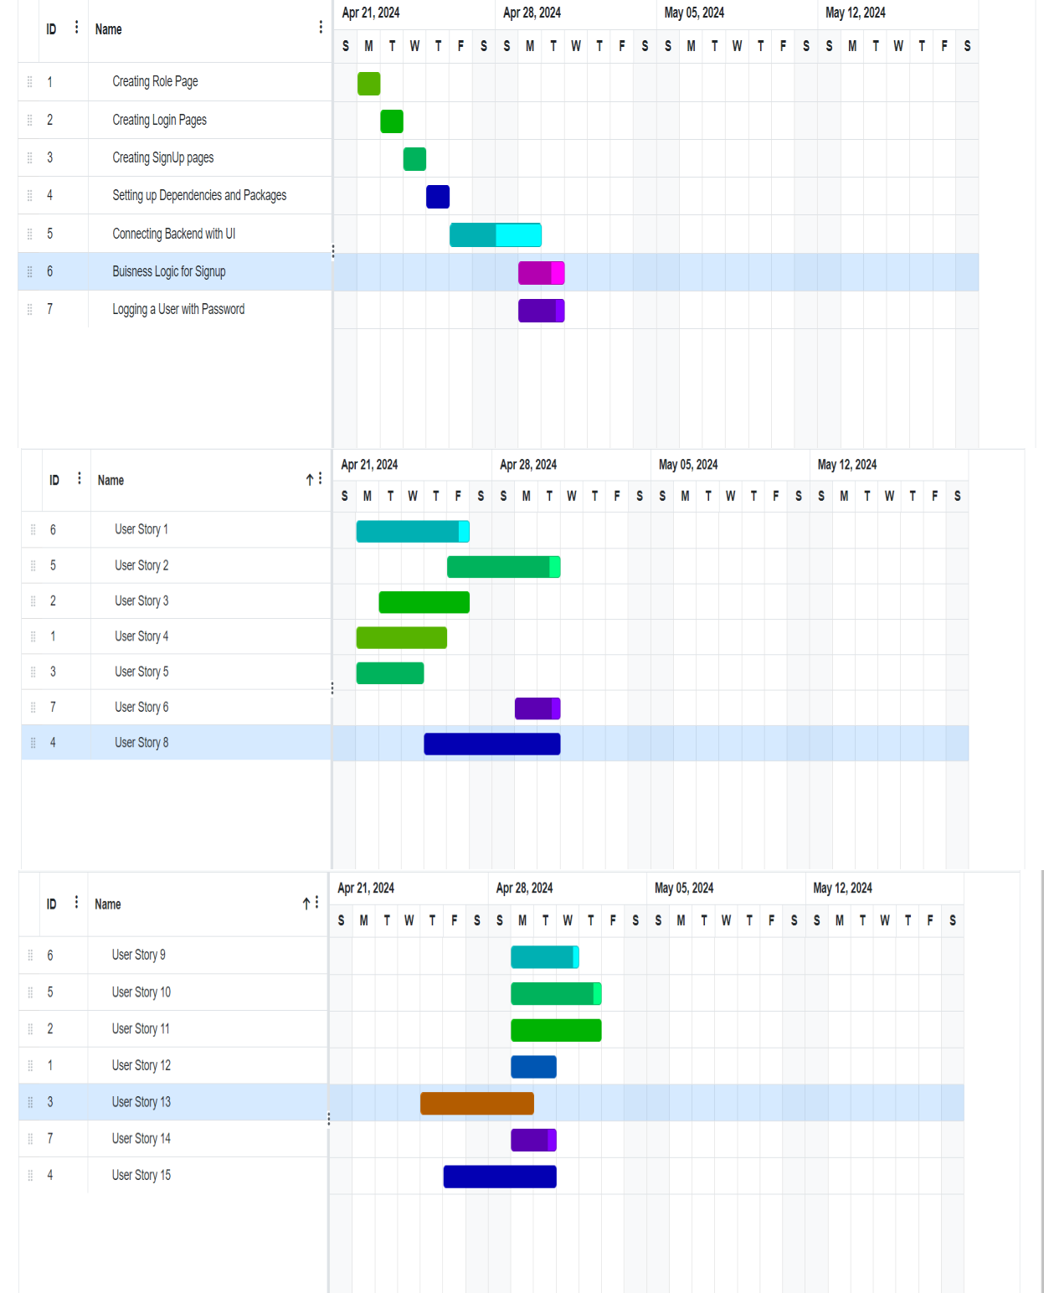

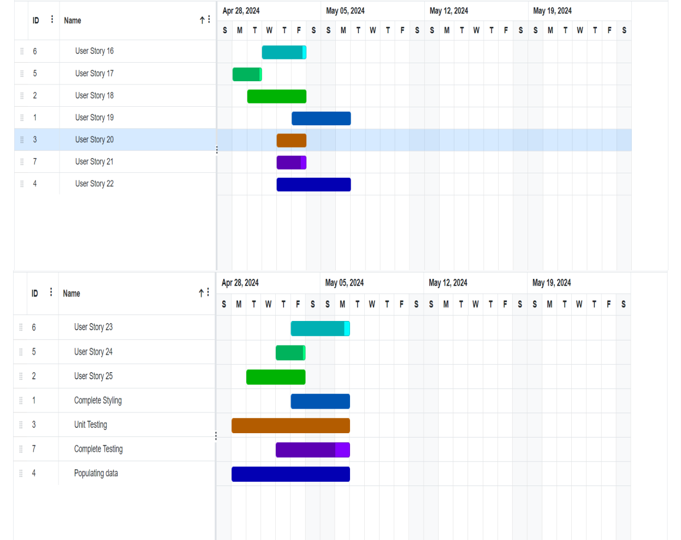

# Trello:

## Sprint 1:

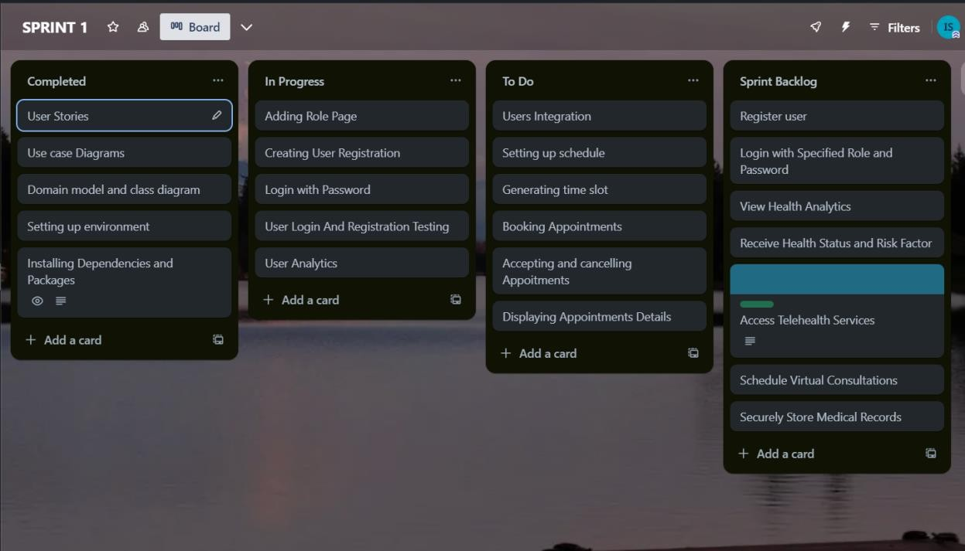

## Sprint 2:

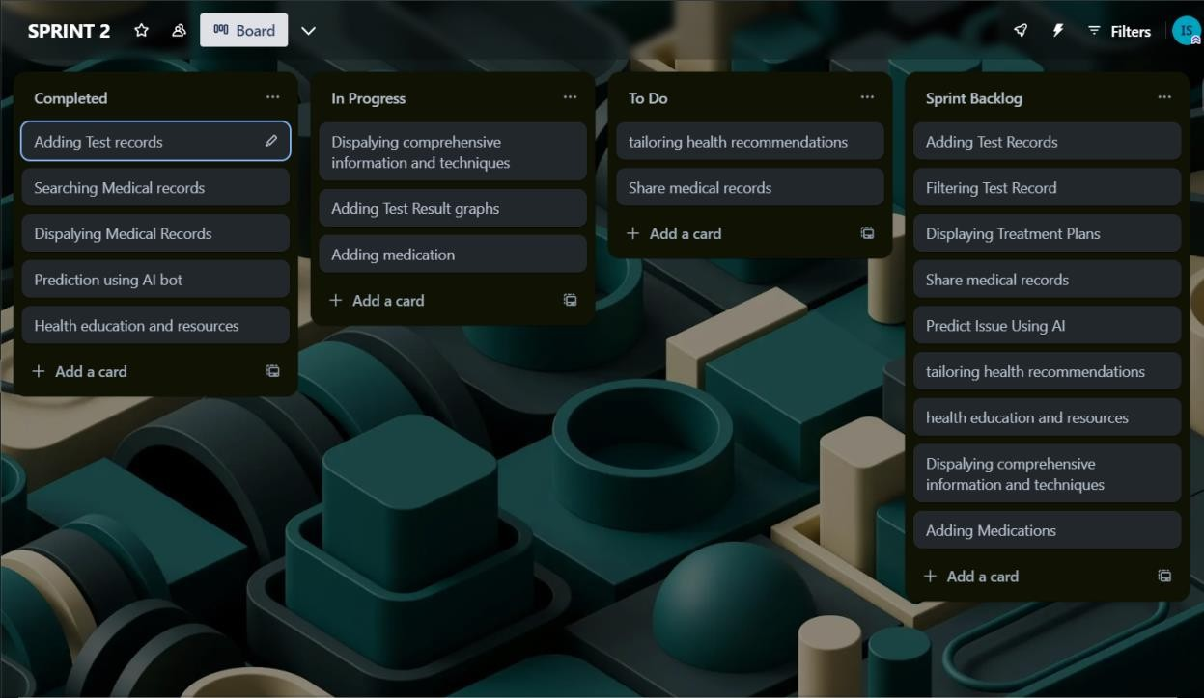

## Sprint 3:

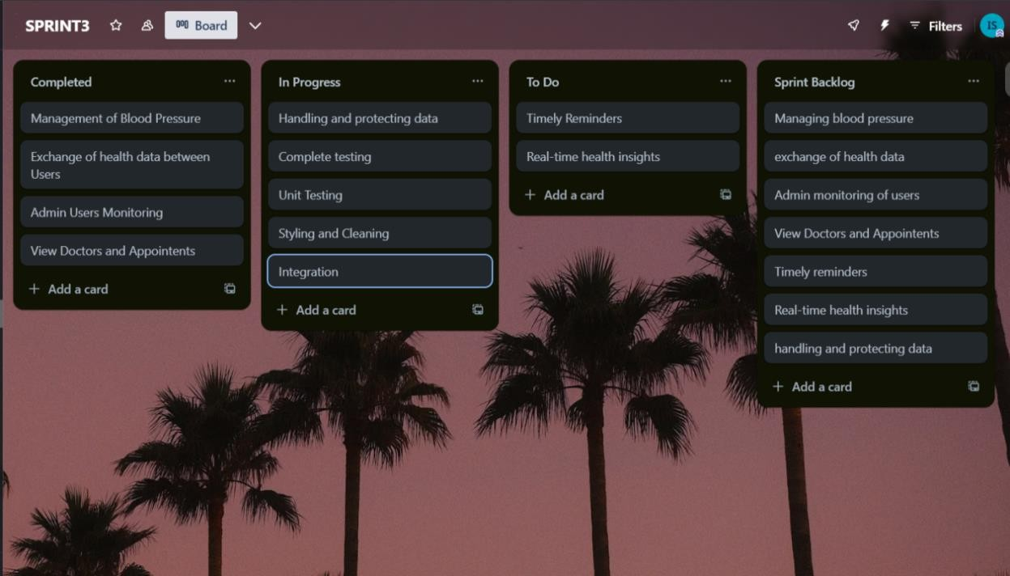

# Product Burndown Chart:

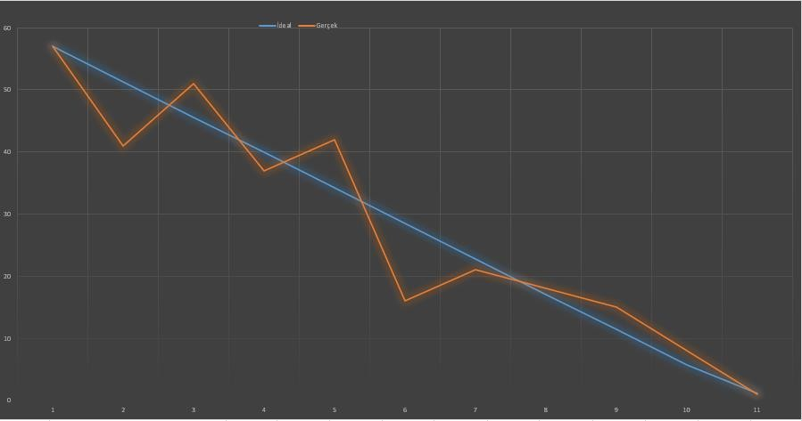

# Project GUI:

The Role Page of HealthHub presents users with three distinct buttons labeled "Client," "Doctor," and "Admin," enabling them to easily select their role within the system. Additionally, the page displays a comprehensive list of doctors, categorized by their specialties, providing users with convenient access to healthcare professionals relevant to their needs.

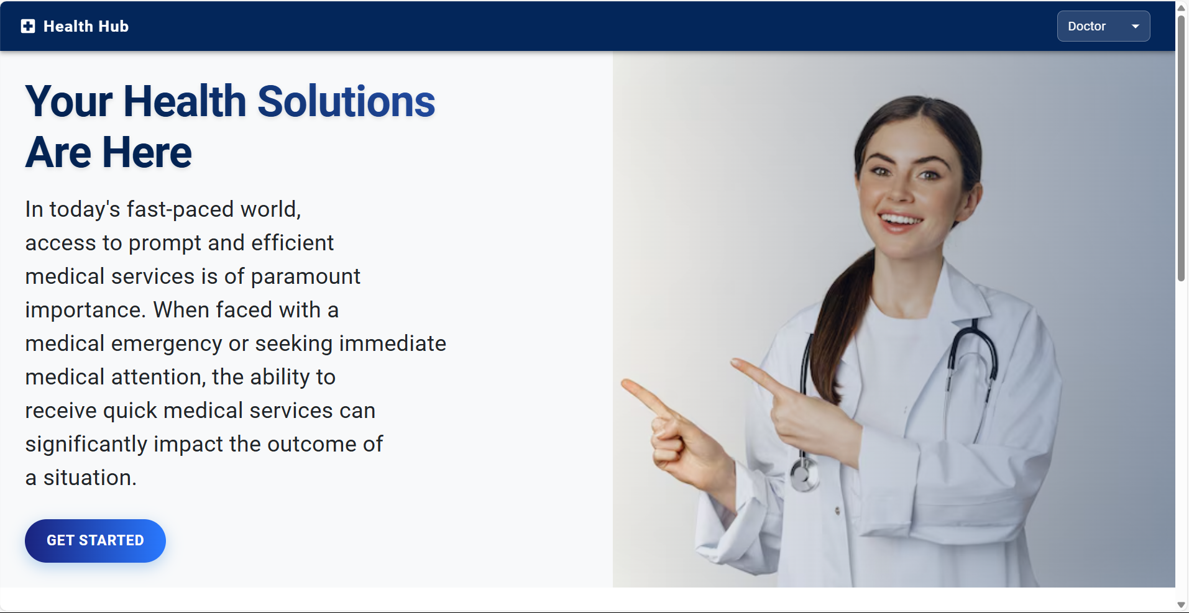

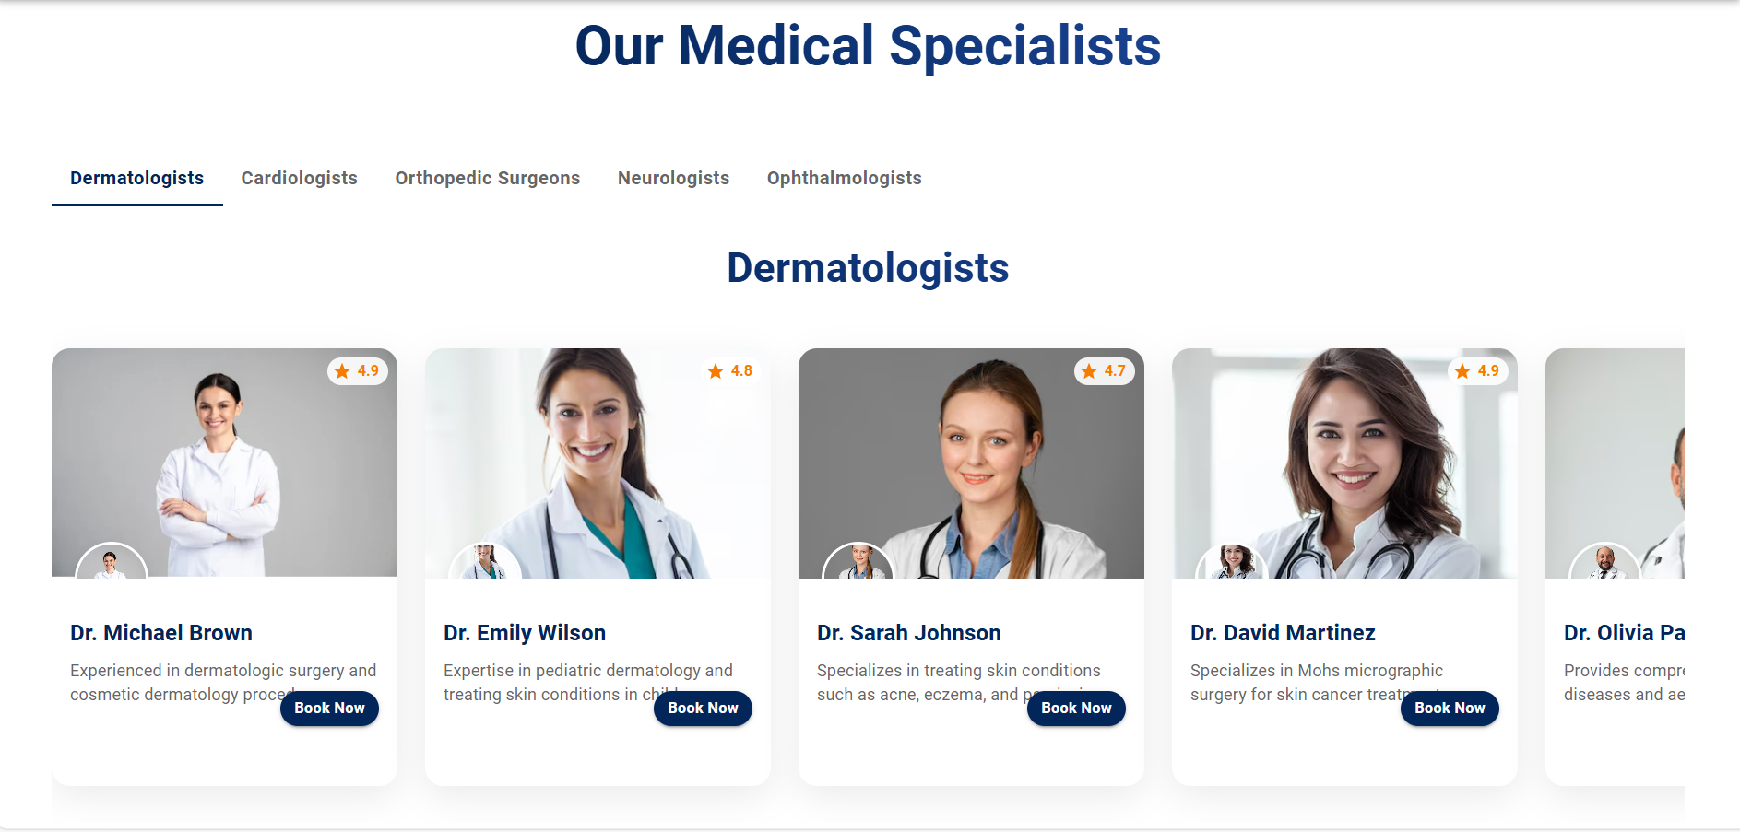

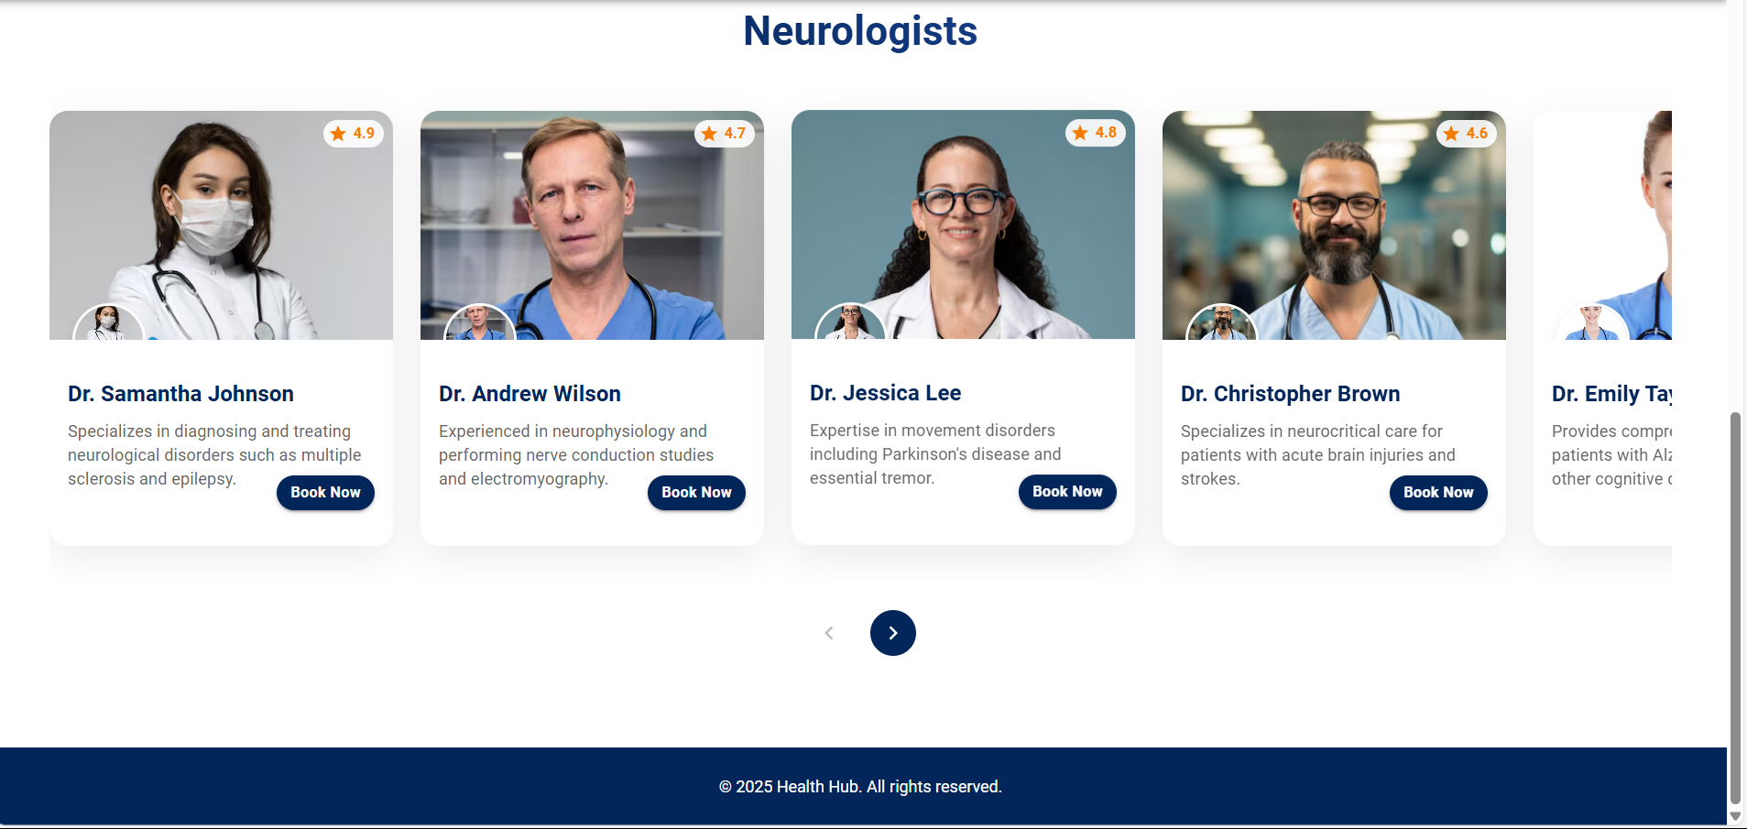

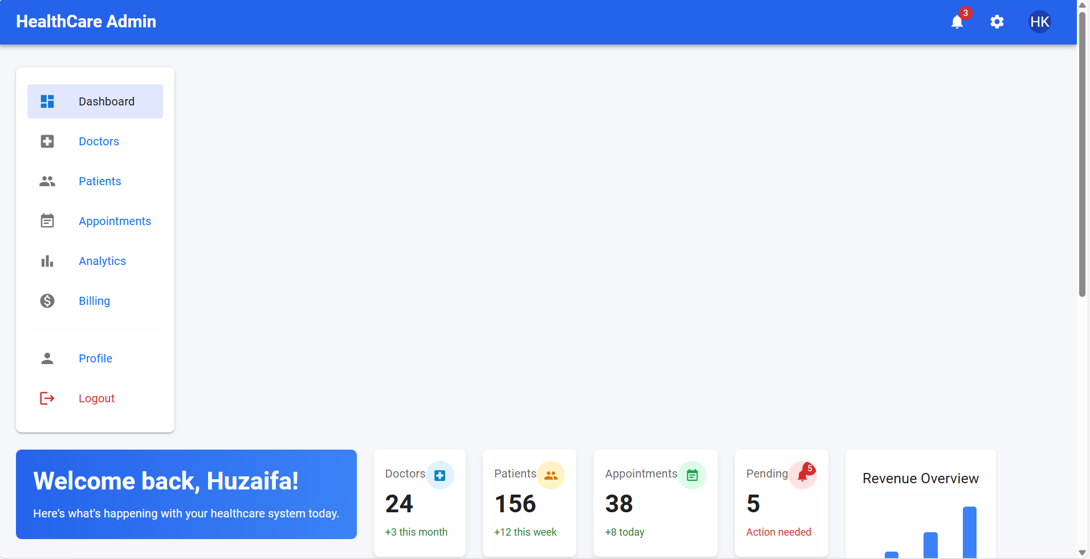

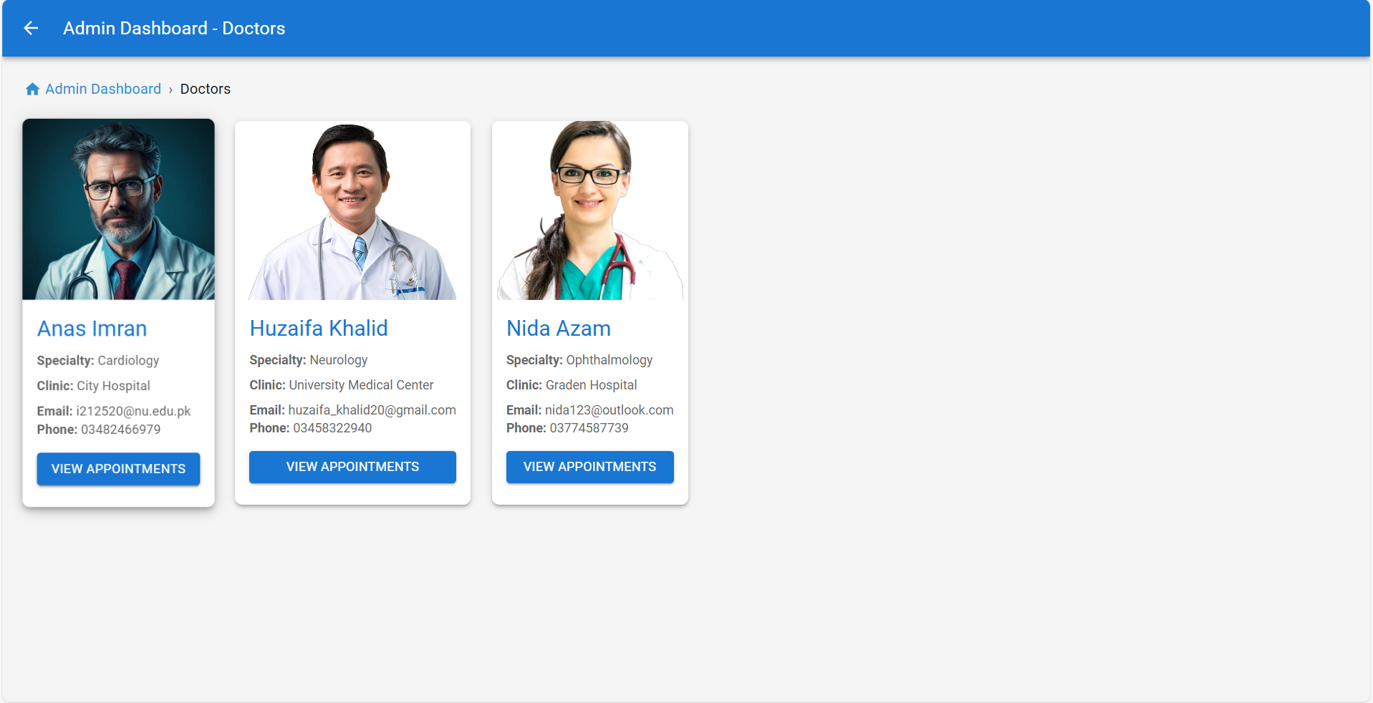

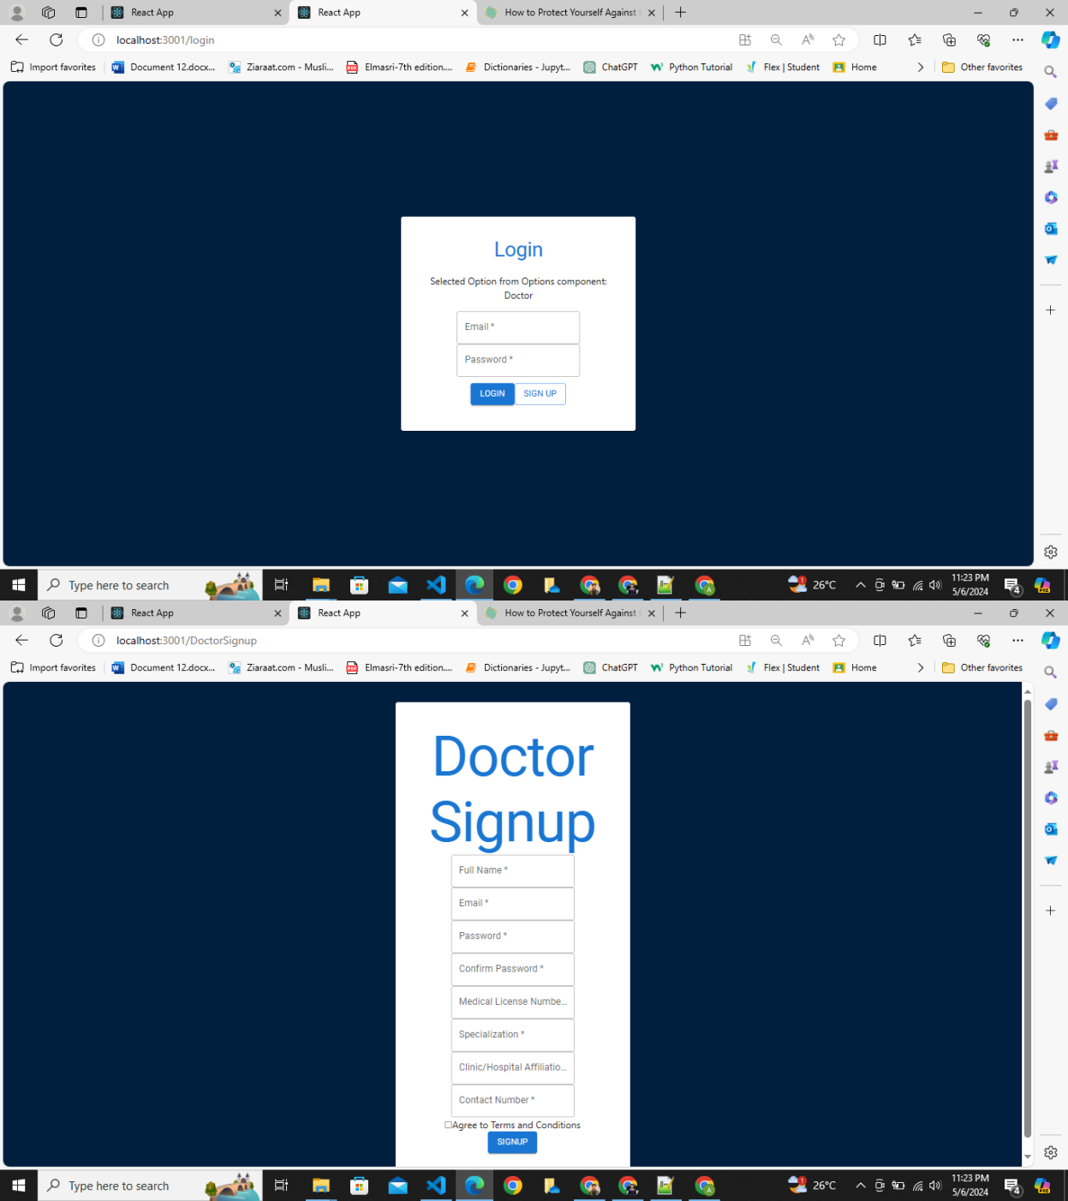

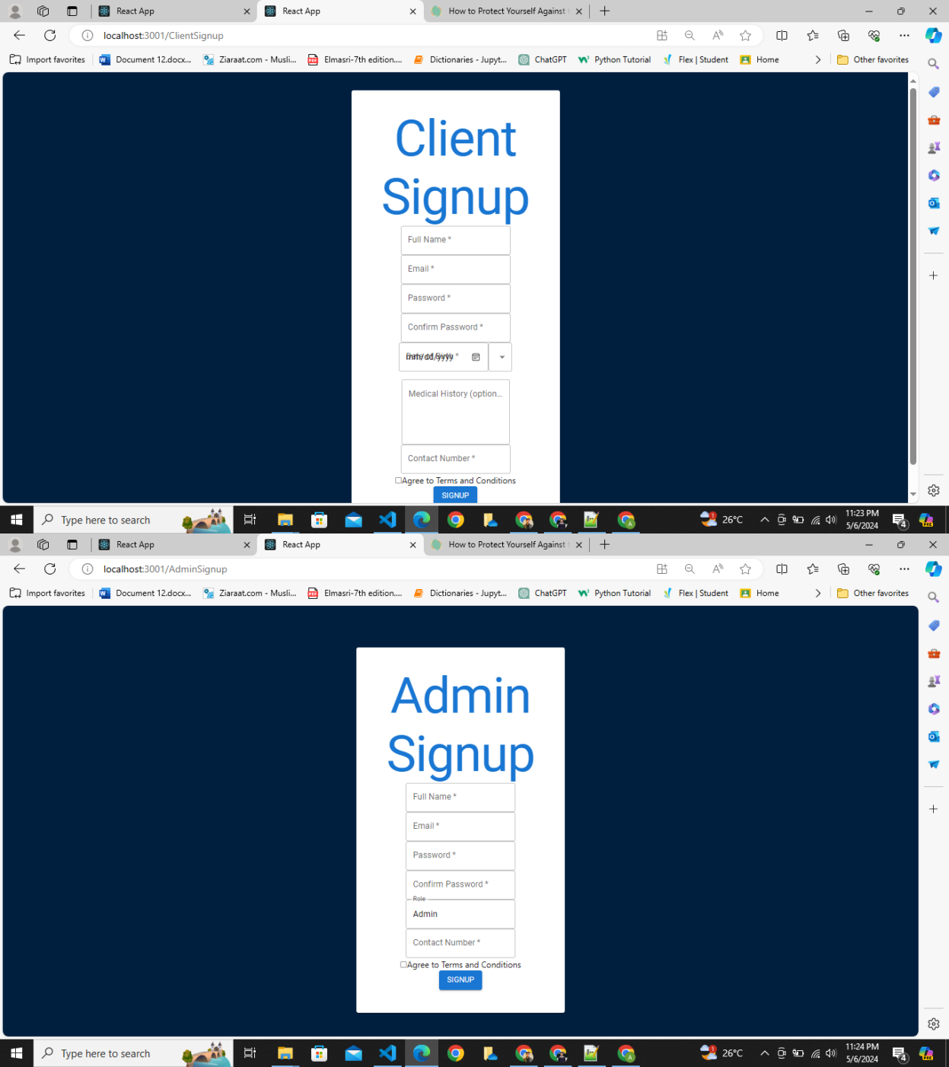

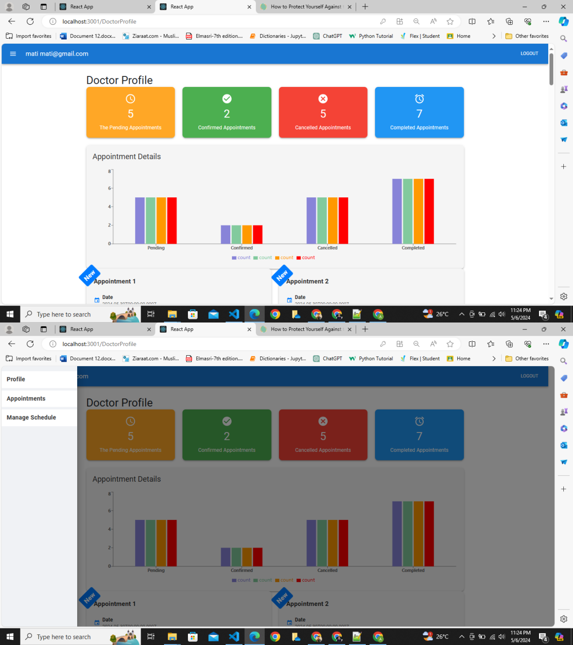

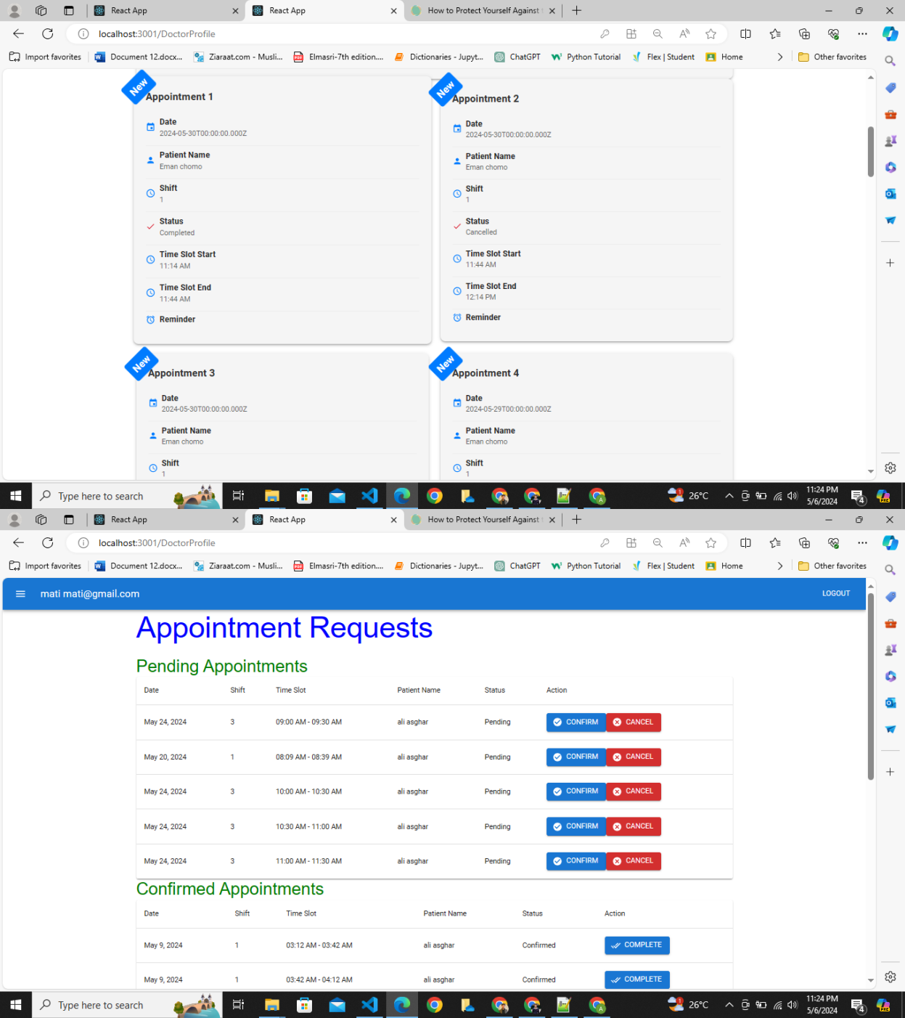

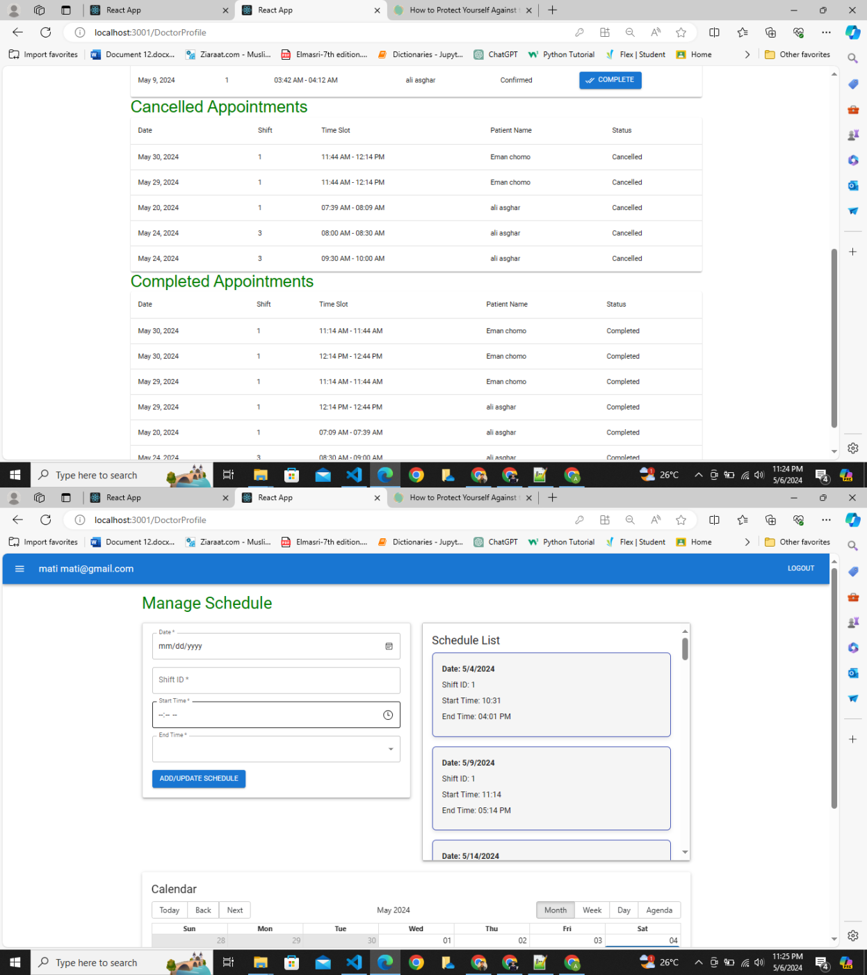

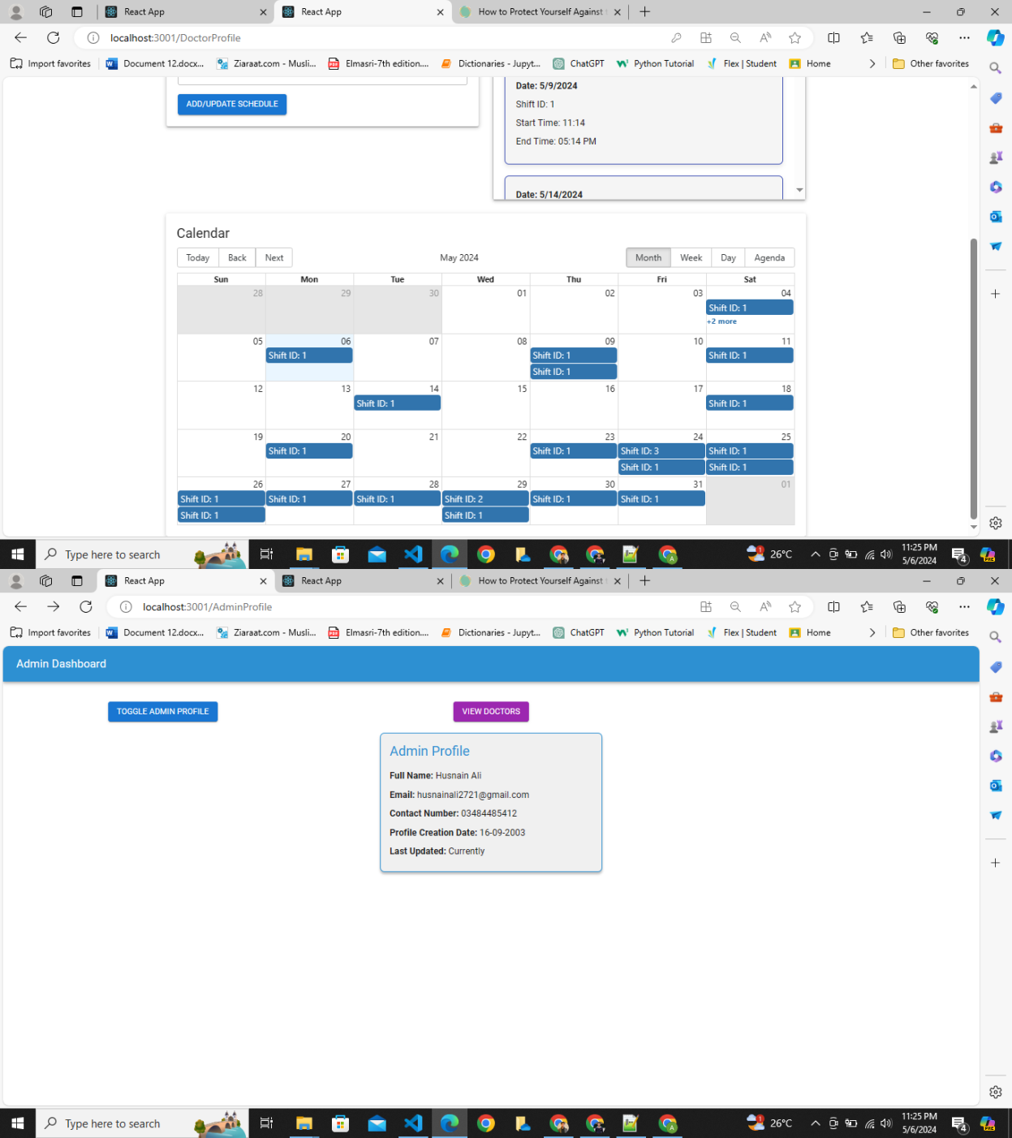

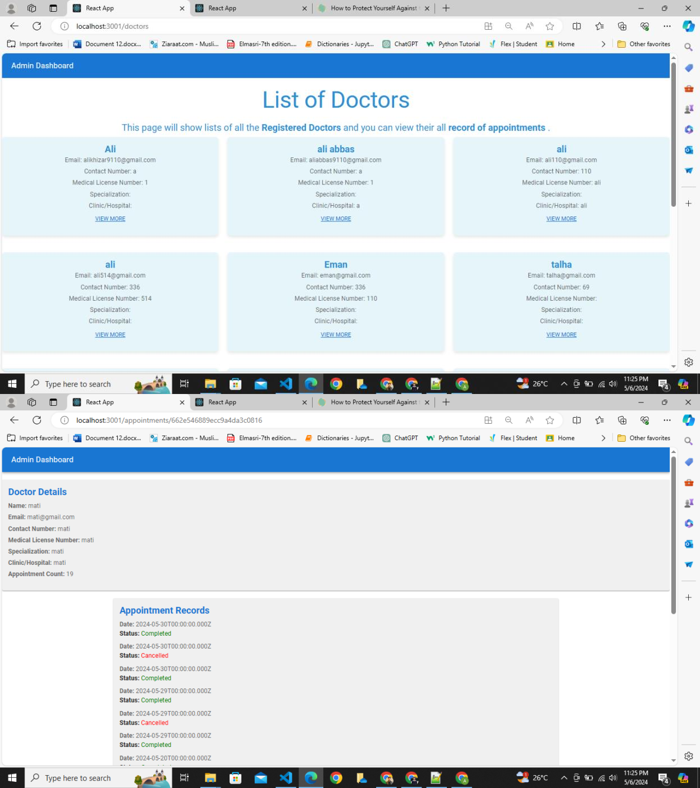

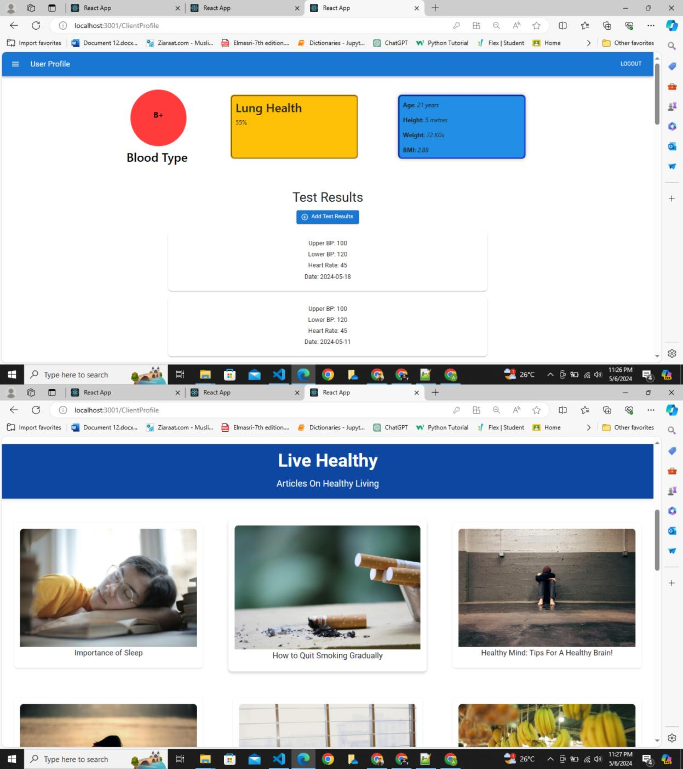

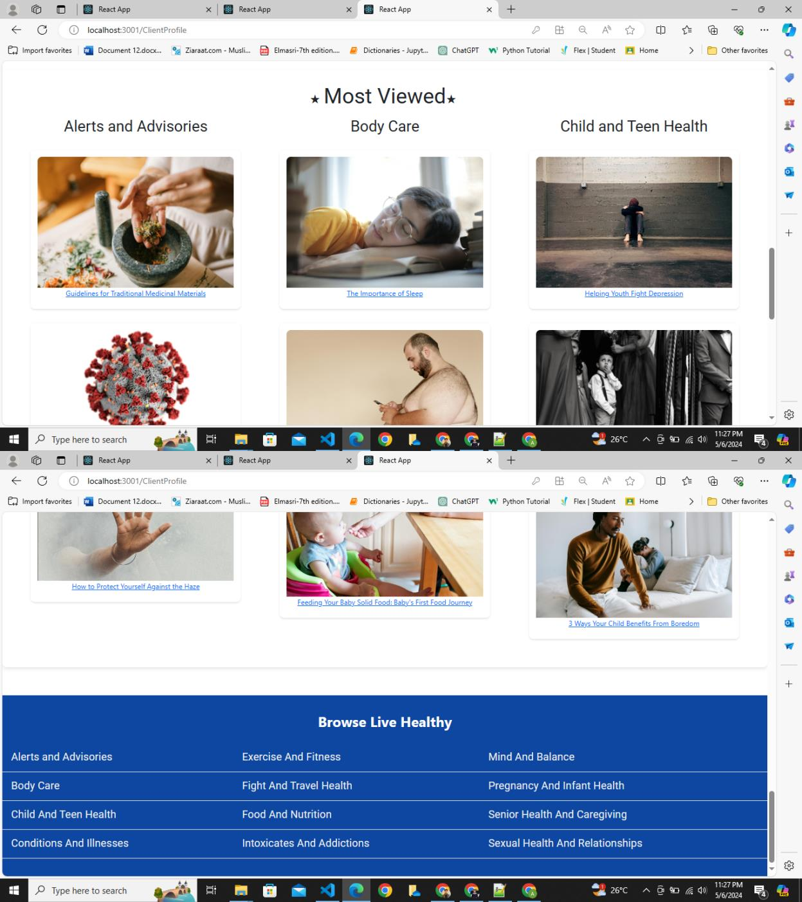

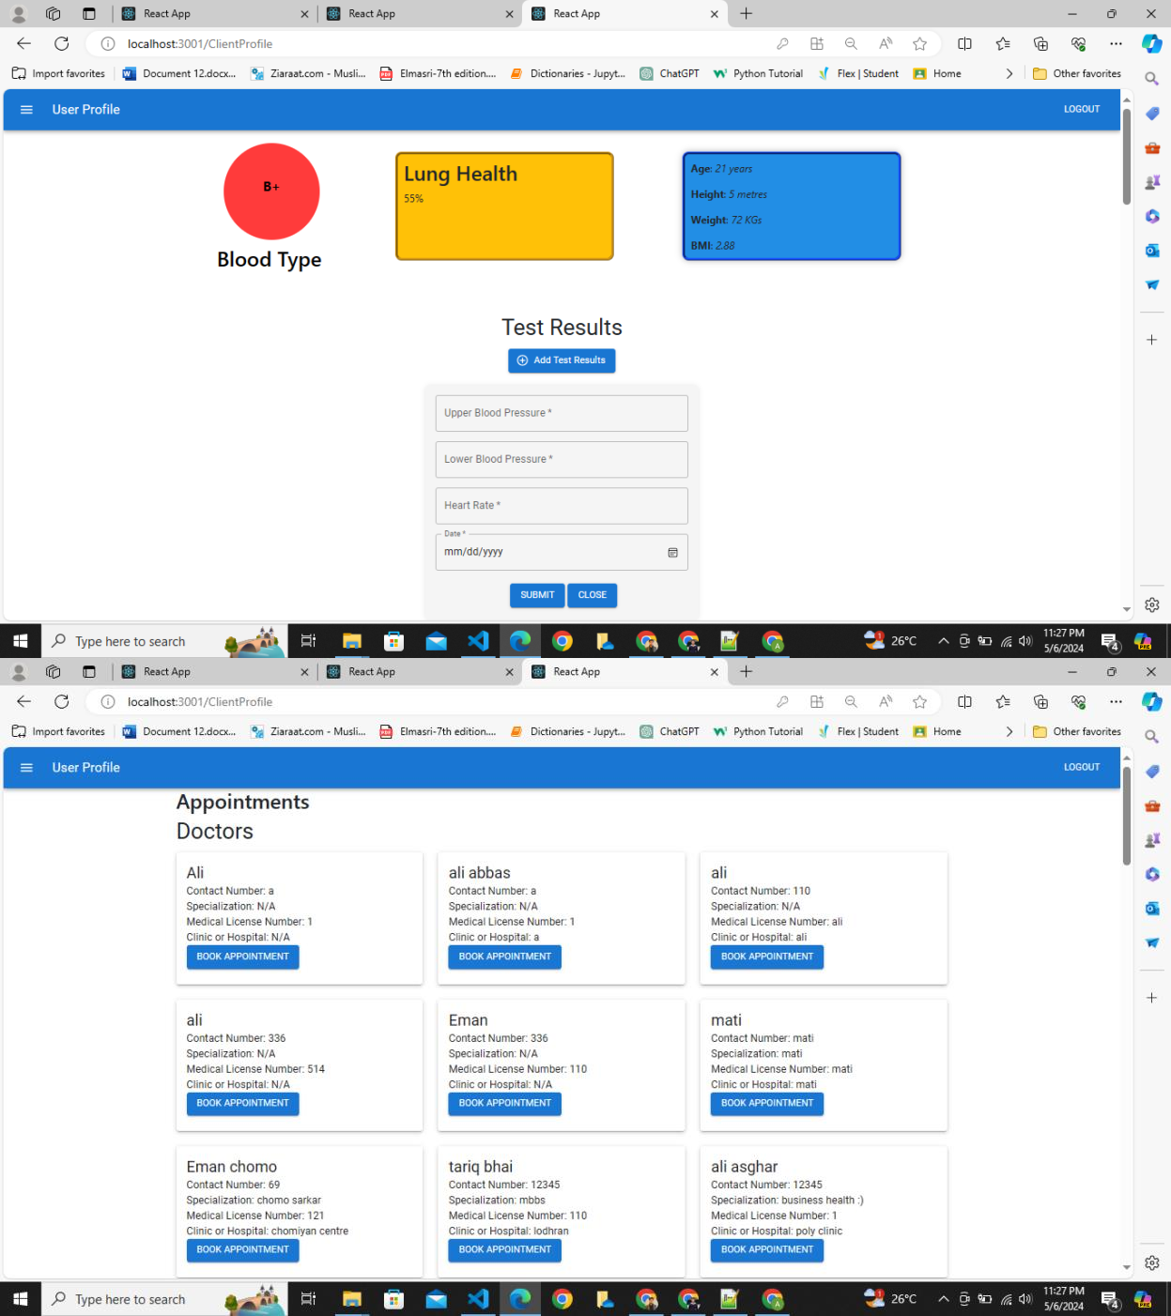

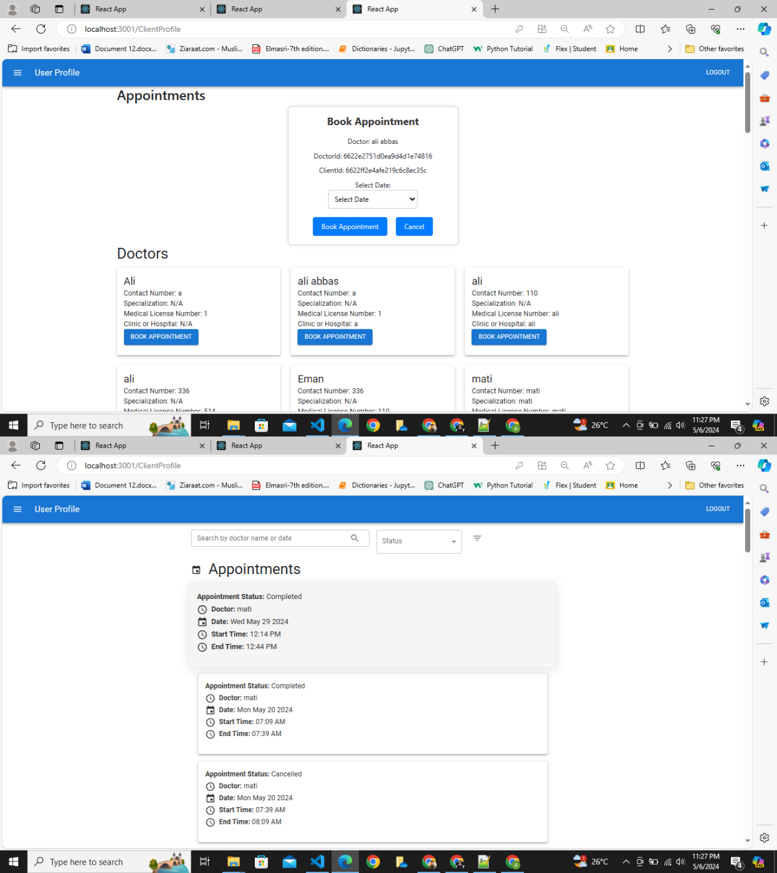

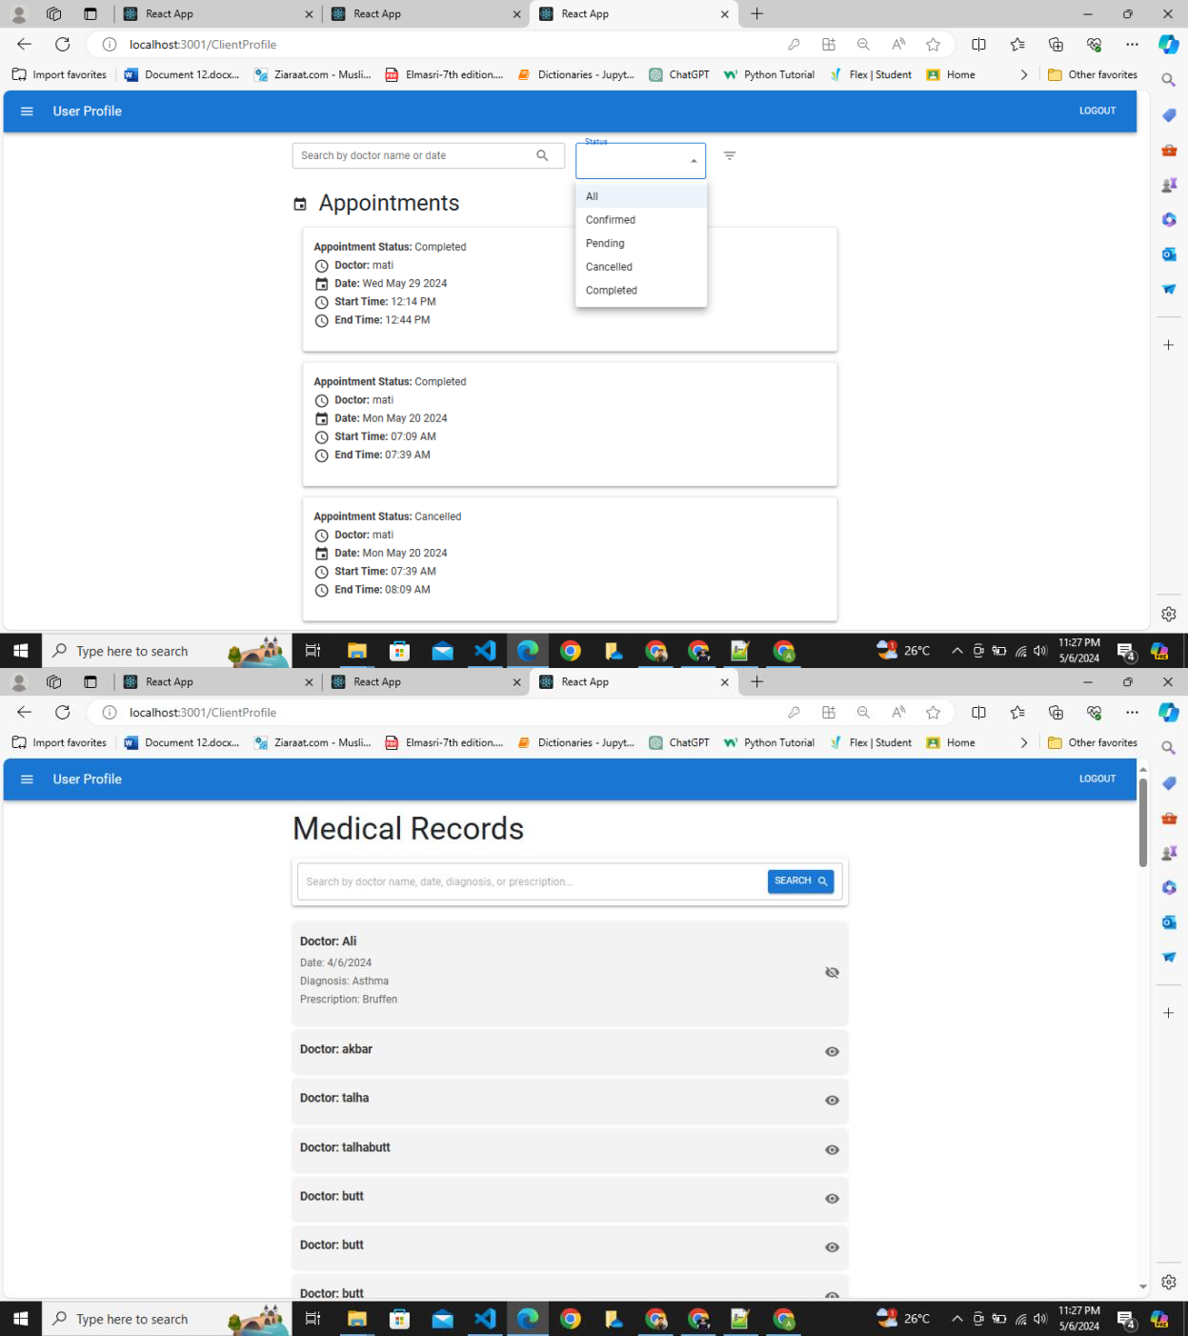

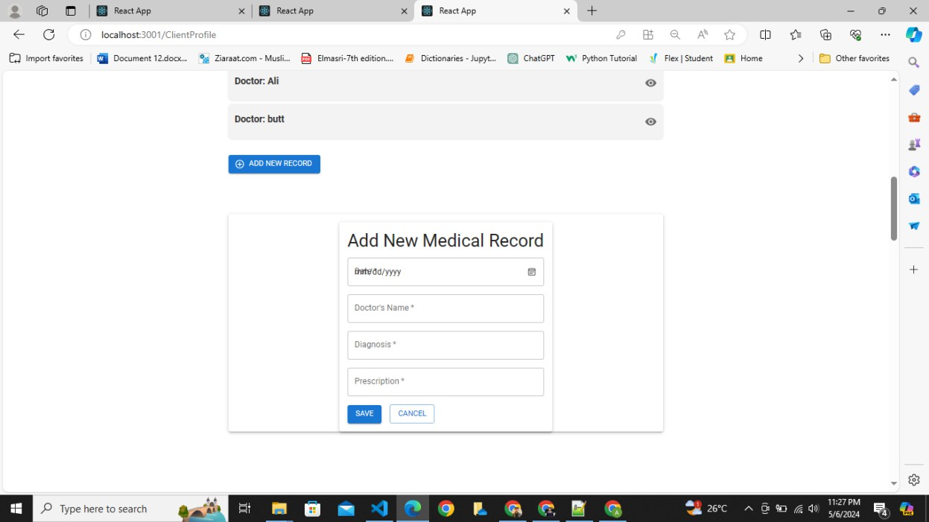

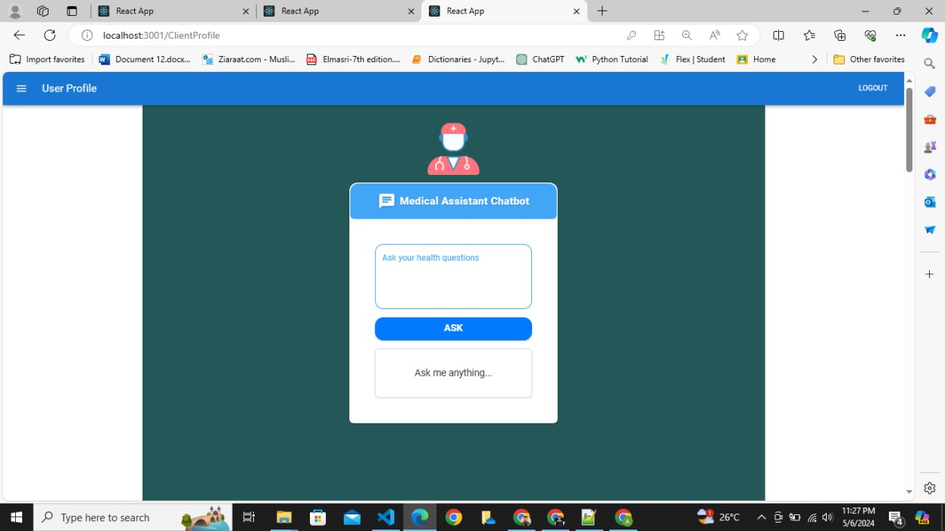

# Equivalent Class Partitions and Boundary Values**:**

## User Story 1: Registration

### Equivalent Class Partitions:

|  |  |  |
| --- | --- | --- |
| **Input or Output Event** | **Valid Equivalence Classes** | **Invalid Equivalence Classes** |
| *Email* field:  The User must enter their Email completely. | @ is a must  .com, .org, .ai, are must | No @ or .com provided |
| *Password:*  The User must provide a password so that they securely access their account. | An upper-case alphabet, a lower-case alphabet, a non- letter character,  6 chars<= Length <= 10 chars (The valid password registered in the database) | No Upper Case Alphabet No Lower-Case Alphabet No non-letter characters Length < 6 chars  Length > 10 chars (anything other than the  password registered in the database) |
| *Confirm Password:*  The User must provide a password so that they  can confirm their password. | Both password and Confirm password must be same. | Confirm Password and Password is not same |
| *Contact Number:*  The User must provide their cell phone number  for communication | Contact number must in n numeric form such as 1,2,3 and so on  It must have 11 digits | It do not have 11 digits (Numeric validation are  completed no one can add other than numeric data) |

### Boundary Value Analysis:

|  |  |
| --- | --- |
| **Input** | **Boundary Value** |
| Email | Minimum valid length of an email address (e.g., 6 characters) |
| Password | Length of Password=6 and Username=10 are the boundary values and should be accepted |
| *Confirm Password:*  The User must provide a password so that they can confirm their password. | Must be Same as password field value |

|  |  |
| --- | --- |
| *Contact Number:* | Contact number <=11 |

## User Story 2: Login

### Equivalent Class Partitions:

|  |  |  |
| --- | --- | --- |
| **Input or Output Event** | **Valid Equivalence Classes** | **Invalid Equivalence Classes** |
| *Email* field:  The User must enter their Email completely. | @ is a must  .com, .org, .ai, are must | No @ or .com provided |
| *Password:*  The User must provide a password so that they securely access their account. | An upper-case alphabet, a lower-case alphabet, a non- letter character,  6 chars<= Length <= 10 chars (The valid password registered in the database) | No Upper Case Alphabet No Lower-Case Alphabet No non-letter characters Length < 6 chars  Length > 10 chars (anything other than the  password registered in the database) |

### Boundary Value Analysis:

|  |  |
| --- | --- |
| **Input** | **Boundary Value** |
| Email | Minimum valid length of an email address (e.g., 6 characters) |
| Password | Length of Password=6 and Username=10 are the boundary values and should be accepted |

## User Story 3: Personalized Health Information

### Equivalent Class Partitions:

|  |  |  |
| --- | --- | --- |
| **Input or Output Event** | **Valid Equivalence Classes** | **Invalid Equivalence Classes** |

|  |  |  |
| --- | --- | --- |
| *Age:*  User must add his age foe basic info to calculate BMI | Must be a number  Must be positive Number | Number out of range Must not positive Number |
| *Height:*  User must add his age foe basic info to calculate BMI | Must be a number  Must be positive Number | Number out of range Must not positive Number |
| *Weight:*  User must add his age foe  basic info to calculate BMI | Must be a number  Must be positive Number | Number out of range Must not positive Number |

### Boundary Value Analysis:

|  |  |
| --- | --- |
| **Input** | **Boundary Value** |
| *Age:* | Length of *Age* <=3 Age>0 |
| *Height:* | Length of *Height* <=1  *Height* >0 |
| *Weight:* | Length of *Height* <=3  *Weight* >0 |

## User Story 4: Test results

### Equivalent Class Partitions:

|  |  |  |
| --- | --- | --- |
| **Input or Output Event** | **Valid Equivalence Classes** | **Invalid Equivalence Classes** |
| Date field:  User must enter date to add test record of that date | Accurate day, month and the year is chosen according to the format | Number out of range Must not positive Number |
| *Upper Blood Pressure:*  User must enter Blood  Pressure to add a test result | Must be a number Must be positive | Number out of range Must not positive Number |
| *Lower Blood Pressure:* User must enter Blood Pressure to add a test  result | Must be a number Must be positive | Number out of range Must not positive Number |

|  |  |  |
| --- | --- | --- |
| *Heartbeat rate:*  User must enter Heart beat rate to add a test  result | Must be a number Must be positive | Number out of range Must not positive Number |

### Boundary Value Analysis:

|  |  |
| --- | --- |
| **Input** | **Boundary Value** |
| Date | Must be less than current date |
| Upper Blood Pressure | Length of Upper Blood Pressure<=3 Upper Blood Pressure>0 |
| Lower Blood Pressure | Length of Lower Blood Pressure <=3 Lower Blood Pressure >0 |
| Heartbeat rate | Length of Heartbeat rate <=3 Heartbeat rate >0 |

## User Story 5: Health Analytics

### Equivalent Class Partitions User Story 5:

|  |  |  |
| --- | --- | --- |
| **Input or Output Event** | **Valid Equivalence Classes** | **Invalid Equivalence Classes** |
| *Health Data estimation:*  User must click the button  provided to check for health data calculation | Clicked only once for estimation  Clicked again for results | Clicked more than once or not at all |
| *Blood type:*  User must choose the blood  type to store the information. | Click to add data  Must choose a value from drop down | Do not clicked  Didn’t selected an option |

#### No Boundary Value Analysis is possible for User Story 5.

## User Story 6: Appointments Management

*Equivalent Class Partitions User Story 6:*

|  |  |  |
| --- | --- | --- |
| **Input or Output Event** | **Valid Equivalence Classes** | **Invalid Equivalence Classes** |
| *Search for Appointments:* User must add Doctor name or specification to get for a specific doctor  slot | Must add alphabetic Data Doctor must be part of System | Data entered other than alphabetic  User not part of system |
| *Select timeslot:*  User must choose a valid timeslot of doctor to ask for appointment  acceptance | Must Select a valid Slot from dropdown data | Did not select a valid slot Did not selected anything |
| *Time slots generation:* User must enter a valid date for generating slots | Must chose a valid date | Date not selected  Did not selected a valid date |
| *Accepting Appointment:* The Doctor must choose the accepted or cancelled to change the status of appointment | Must click on the button provided | Did not clicked the button provided |

### Boundary Value Analysis:

|  |  |
| --- | --- |
| **Input** | **Boundary Value** |
| Search for Appointments | Must be in alphabetic form. Any text with length>=0 |
| Select timeslot date | Must be in range  Year and month must be current |

## 1. Equivalence Class Partitioning for Patient UI Fields

Let's create equivalence classes for common fields in a patient management system:

### Patient Name Field

### 

### Email Field

### 

### Phone Number Field

### 

### Date of Birth Field

### 

### Blood Type Field

## 

## 2. Number of Test Cases for Weak and Strong Equivalence Class Testing

### Weak Equivalence Class Testing

In weak equivalence class testing, we select one test case from each equivalence class. This gives us:

* Patient Name: 3 valid + 5 invalid = 8 test cases
* Email: 3 valid + 5 invalid = 8 test cases
* Phone Number: 3 valid + 5 invalid = 8 test cases
* Date of Birth: 3 valid + 4 invalid = 7 test cases
* Blood Type: 1 valid + 4 invalid = 5 test cases

Total for weak equivalence class testing: 36 test cases

### Strong Equivalence Class Testing

In strong equivalence class testing, we test all possible combinations of equivalence classes. This would result in a very large number of test cases:

For all fields combined, this would be: (3+5) × (3+5) × (3+5) × (3+4) × (1+4) = 8 × 8 × 8 × 7 × 5 = 17,920 test cases

This is impractical, so typically we would do strong equivalence class testing for individual fields or targeted combinations.

## 3. Boundary Values for Each Field

### Patient Name Field

* Lower boundary: 2 characters
* Upper boundary: 50 characters
* Test values: 1 character, 2 characters, 3 characters, 49 characters, 50 characters, 51 characters

### Email Field

* Boundary for username part: empty, 1 character, 64 characters (RFC standard)
* Boundary for domain part: 1 character + TLD, 255 characters total
* Test values: minimum valid email ([a@b.c](mailto:a@b.c)), maximum username (64 chars), maximum domain length

### Phone Number Field

* Lower boundary: 10 digits
* Upper boundary: 15 digits (including country code)
* Test values: 9 digits, 10 digits, 11 digits, 15 digits, 16 digits

## 1. Equivalence Class Partitioning for Doctor UI Fields

### Doctor Name Field

### 

### Email Field

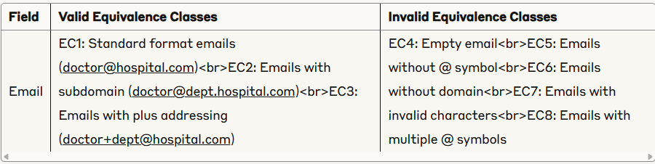

| Specialty/Specialization Field |  |  |
| --- | --- | --- |
|  |  |  |
|  | | | |  |  |
|  | | | |  |  |

|  |  |  |
| --- | --- | --- |
|  |  |  |

### Medical License Number Field

|  |  |  |
| --- | --- | --- |
|  |  |  |

### Clinic/Hospital Field

|  |  |  |
| --- | --- | --- |
|  |  |  |

### Contact Number Field

|  |  |  |
| --- | --- | --- |
|  |  |  |

## 2. Number of Test Cases for Weak and Strong Equivalence Class Testing

### Weak Equivalence Class Testing

* Doctor Name: 3 valid + 5 invalid = 8 test cases
* Email: 3 valid + 5 invalid = 8 test cases
* Specialization: 3 valid + 4 invalid = 7 test cases
* License Number: 2 valid + 4 invalid = 6 test cases
* Clinic/Hospital: 2 valid + 4 invalid = 6 test cases
* Contact Number: 3 valid + 5 invalid = 8 test cases

Total for weak equivalence class testing: 43 test cases

### Strong Equivalence Class Testing

For all doctor fields combined, this would be extremely large. In practice, we would apply strong testing to key combinations or individual fields.

## 3. Boundary Values for Doctor UI Fields

### Doctor Name Field

* Lower boundary: 2 characters
* Upper boundary: 50 characters
* Test values: 1 character, 2 characters, 3 characters, 49 characters, 50 characters, 51 characters

### Email Field

* Same as for Patient UI

### Specialization Field

* Lower boundary: 2 characters
* Upper boundary: 50 characters
* Test values: 1 character, 2 characters, 3 characters, 49 characters, 50 characters, 51 characters

### License Number Field

* Boundaries depend on specific format requirements of your system
* Typical test values: minimum valid length, maximum valid length, one character less, one character more

### Clinic/Hospital Field

* Lower boundary: 2 characters
* Upper boundary: 100 characters
* Test values: 1 character, 2 characters, 3 characters, 99 characters, 100 characters, 101 characters

### Contact Number Field

# Same as for Patient UI

**Katalon Studio Test Scripts for Patient UI**

import static com.kms.katalon.core.checkpoint.CheckpointFactory.findCheckpoint

import static com.kms.katalon.core.testcase.TestCaseFactory.findTestCase

import static com.kms.katalon.core.testdata.TestDataFactory.findTestData

import static com.kms.katalon.core.testobject.ObjectRepository.findTestObject

import com.kms.katalon.core.webui.keyword.WebUiBuiltInKeywords as WebUI

import com.kms.katalon.core.mobile.keyword.MobileBuiltInKeywords as Mobile

import com.kms.katalon.core.webservice.keyword.WSBuiltInKeywords as WS

import com.kms.katalon.core.testobject.TestObject

import internal.GlobalVariable as GlobalVariable

/**

* Test Suite for Patient UI in Admin View

*/

// Test Case 1: Valid Patient Data Entry

def testValidPatientDataEntry() {

// Open the Admin Patient View page

WebUI.openBrowser('')

WebUI.navigateToUrl('http://localhost:3000/admin/patients')

WebUI.maximizeWindow()

// Log in as admin if required

WebUI.setText(findTestObject('Admin/LoginPage/input_username'), 'admin')

WebUI.setText(findTestObject('Admin/LoginPage/input_password'), 'admin123')

WebUI.click(findTestObject('Admin/LoginPage/button_login'))

// Verify page loaded correctly

WebUI.verifyElementPresent(findTestObject('Admin/PatientView/header_patients'), 10)

// Test navigation and UI presence

WebUI.verifyElementPresent(findTestObject('Admin/PatientView/breadcrumb_admin'), 5)

WebUI.verifyElementPresent(findTestObject('Admin/PatientView/breadcrumb_patients'), 5)

WebUI.verifyElementPresent(findTestObject('Admin/PatientView/button_back'), 5)

// Verify patient cards are loaded

WebUI.verifyElementPresent(findTestObject('Admin/PatientView/patient_cards'), 10)

// Close browser

WebUI.closeBrowser()

}

// Test Case 2: Patient Search - Valid Input

def testPatientSearch() {

WebUI.openBrowser('')

WebUI.navigateToUrl('http://localhost:3000/admin/patients')

// Verify search field is present

WebUI.verifyElementPresent(findTestObject('Admin/PatientView/input_search'), 5)

// Test with valid search term (assuming "John" exists in the data)

WebUI.setText(findTestObject('Admin/PatientView/input_search'), 'John')

WebUI.click(findTestObject('Admin/PatientView/button_search'))

// Verify search results

WebUI.verifyElementPresent(findTestObject('Admin/PatientView/search_results'), 5)

WebUI.verifyTextPresent('John', false)

// Close browser

WebUI.closeBrowser()

}

// Test Case 3: Patient Detail View

def testPatientDetailView() {

WebUI.openBrowser('')

WebUI.navigateToUrl('http://localhost:3000/admin/patients')

// Click on first patient card's "View Details" button

WebUI.click(findTestObject('Admin/PatientView/button_viewDetails'))

// Verify patient details page loaded

WebUI.verifyElementPresent(findTestObject('Admin/PatientDetail/header_patientDetail'), 5)

// Verify key patient information is displayed

WebUI.verifyElementPresent(findTestObject('Admin/PatientDetail/label_name'), 5)

WebUI.verifyElementPresent(findTestObject('Admin/PatientDetail/label_email'), 5)

WebUI.verifyElementPresent(findTestObject('Admin/PatientDetail/label_phone'), 5)

WebUI.verifyElementPresent(findTestObject('Admin/PatientDetail/label_dob'), 5)

WebUI.verifyElementPresent(findTestObject('Admin/PatientDetail/label_bloodType'), 5)

// Close browser

WebUI.closeBrowser()

}

// Test Case 4: Patient Field Validation - Name Field

def testPatientNameFieldValidation() {

WebUI.openBrowser('')

WebUI.navigateToUrl('http://localhost:3000/admin/patients/add')

// Boundary value testing for name field

// Test 1: Empty name (invalid)

WebUI.setText(findTestObject('Admin/PatientAdd/input_name'), '')

WebUI.click(findTestObject('Admin/PatientAdd/button_submit'))

WebUI.verifyElementPresent(findTestObject('Admin/PatientAdd/error_name'), 5)

WebUI.verifyTextPresent('Name is required', false)

// Test 2: Name with 1 character (invalid)

WebUI.setText(findTestObject('Admin/PatientAdd/input_name'), 'A')

WebUI.click(findTestObject('Admin/PatientAdd/button_submit'))

WebUI.verifyElementPresent(findTestObject('Admin/PatientAdd/error_name'), 5)

WebUI.verifyTextPresent('Name must be at least 2 characters', false)

// Test 3: Name with 2 characters (valid - boundary)

WebUI.setText(findTestObject('Admin/PatientAdd/input_name'), 'Ab')

// Continue with other fields to validate form submission

WebUI.setText(findTestObject('Admin/PatientAdd/input_email'), 'valid@example.com')

WebUI.setText(findTestObject('Admin/PatientAdd/input_phone'), '1234567890')

WebUI.setText(findTestObject('Admin/PatientAdd/input_dob'), '01/01/1990')

WebUI.click(findTestObject('Admin/PatientAdd/button_submit'))

WebUI.verifyElementNotPresent(findTestObject('Admin/PatientAdd/error_name'), 5)

// Test 4: Name with 50 characters (valid - boundary)

def fiftyCharName = 'A' * 50

WebUI.setText(findTestObject('Admin/PatientAdd/input_name'), fiftyCharName)

WebUI.click(findTestObject('Admin/PatientAdd/button_submit'))

WebUI.verifyElementNotPresent(findTestObject('Admin/PatientAdd/error_name'), 5)

// Test 5: Name with 51 characters (invalid)

def fiftyOneCharName = 'A' * 51

WebUI.setText(findTestObject('Admin/PatientAdd/input_name'), fiftyOneCharName)

WebUI.click(findTestObject('Admin/PatientAdd/button_submit'))

WebUI.verifyElementPresent(findTestObject('Admin/PatientAdd/error_name'), 5)

WebUI.verifyTextPresent('Name must be at most 50 characters', false)

// Test 6: Name with special characters (invalid)

WebUI.setText(findTestObject('Admin/PatientAdd/input_name'), 'John$Smith')

WebUI.click(findTestObject('Admin/PatientAdd/button_submit'))

WebUI.verifyElementPresent(findTestObject('Admin/PatientAdd/error_name'), 5)

WebUI.verifyTextPresent('Name contains invalid characters', false)

// Close browser

WebUI.closeBrowser()

}

// Test Case 5: Patient Field Validation - Email Field

def testPatientEmailFieldValidation() {

WebUI.openBrowser('')

WebUI.navigateToUrl('http://localhost:3000/admin/patients/add')

// Test 1: Empty email (invalid)

WebUI.setText(findTestObject('Admin/PatientAdd/input_email'), '')

WebUI.click(findTestObject('Admin/PatientAdd/button_submit'))

WebUI.verifyElementPresent(findTestObject('Admin/PatientAdd/error_email'), 5)

WebUI.verifyTextPresent('Email is required', false)

// Test 2: Invalid email format (missing @)

WebUI.setText(findTestObject('Admin/PatientAdd/input_email'), 'invalidemail.com')

WebUI.click(findTestObject('Admin/PatientAdd/button_submit'))

WebUI.verifyElementPresent(findTestObject('Admin/PatientAdd/error_email'), 5)

WebUI.verifyTextPresent('Invalid email format', false)

// Test 3: Invalid email format (missing domain)

WebUI.setText(findTestObject('Admin/PatientAdd/input_email'), 'invalid@')

WebUI.click(findTestObject('Admin/PatientAdd/button_submit'))

WebUI.verifyElementPresent(findTestObject('Admin/PatientAdd/error_email'), 5)

WebUI.verifyTextPresent('Invalid email format', false)

// Test 4: Valid email

WebUI.setText(findTestObject('Admin/PatientAdd/input_email'), 'valid@example.com')

// Add other required fields for form validation

WebUI.setText(findTestObject('Admin/PatientAdd/input_name'), 'John Doe')

WebUI.setText(findTestObject('Admin/PatientAdd/input_phone'), '1234567890')

WebUI.setText(findTestObject('Admin/PatientAdd/input_dob'), '01/01/1990')

WebUI.click(findTestObject('Admin/PatientAdd/button_submit'))

WebUI.verifyElementNotPresent(findTestObject('Admin/PatientAdd/error_email'), 5)

// Close browser

WebUI.closeBrowser()

}

// Test Case 6: Patient Date of Birth Validation

def testPatientDOBValidation() {

WebUI.openBrowser('')

WebUI.navigateToUrl('http://localhost:3000/admin/patients/add')

// Test 1: Empty DOB (invalid)

WebUI.setText(findTestObject('Admin/PatientAdd/input_dob'), '')

WebUI.click(findTestObject('Admin/PatientAdd/button_submit'))

WebUI.verifyElementPresent(findTestObject('Admin/PatientAdd/error_dob'), 5)

WebUI.verifyTextPresent('Date of birth is required', false)

// Test 2: Future date (invalid)

def futureDate = new Date() + 30 // 30 days in the future

def futureDateStr = futureDate.format('MM/dd/yyyy')

WebUI.setText(findTestObject('Admin/PatientAdd/input_dob'), futureDateStr)

WebUI.click(findTestObject('Admin/PatientAdd/button_submit'))

WebUI.verifyElementPresent(findTestObject('Admin/PatientAdd/error_dob'), 5)

WebUI.verifyTextPresent('Date of birth cannot be in the future', false)

// Test 3: Valid date

WebUI.setText(findTestObject('Admin/PatientAdd/input_dob'), '01/01/1990')

// Add other required fields for form validation

WebUI.setText(findTestObject('Admin/PatientAdd/input_name'), 'John Doe')

WebUI.setText(findTestObject('Admin/PatientAdd/input_email'), 'valid@example.com')

WebUI.setText(findTestObject('Admin/PatientAdd/input_phone'), '1234567890')

WebUI.click(findTestObject('Admin/PatientAdd/button_submit'))

WebUI.verifyElementNotPresent(findTestObject('Admin/PatientAdd/error_dob'), 5)

// Close browser

WebUI.closeBrowser()

}

// Test Case 7: Patient Blood Type Validation

def testPatientBloodTypeValidation() {

WebUI.openBrowser('')

WebUI.navigateToUrl('http://localhost:3000/admin/patients/add')

// Test 1: Invalid blood type

WebUI.selectOptionByValue(findTestObject('Admin/PatientAdd/select_bloodType'), 'invalid', false)

WebUI.click(findTestObject('Admin/PatientAdd/button_submit'))

WebUI.verifyElementPresent(findTestObject('Admin/PatientAdd/error_bloodType'), 5)

WebUI.verifyTextPresent('Invalid blood type selected', false)

// Test 2: Valid blood type

WebUI.selectOptionByValue(findTestObject('Admin/PatientAdd/select_bloodType'), 'A+', false)

// Add other required fields for form validation

WebUI.setText(findTestObject('Admin/PatientAdd/input_name'), 'John Doe')

WebUI.setText(findTestObject('Admin/PatientAdd/input_email'), 'valid@example.com')

WebUI.setText(findTestObject('Admin/PatientAdd/input_phone'), '1234567890')

WebUI.setText(findTestObject('Admin/PatientAdd/input_dob'), '01/01/1990')

WebUI.click(findTestObject('Admin/PatientAdd/button_submit'))

WebUI.verifyElementNotPresent(findTestObject('Admin/PatientAdd/error_bloodType'), 5)

// Close browser

WebUI.closeBrowser()

}

// Test Case 8: View Patient Medical History

def testPatientMedicalHistory() {

WebUI.openBrowser('')

WebUI.navigateToUrl('http://localhost:3000/admin/patients')

// Click on the first patient's "Medical History" button

WebUI.click(findTestObject('Admin/PatientView/button_medicalHistory'))

// Verify medical history page loaded

WebUI.verifyElementPresent(findTestObject('Admin/PatientMedicalHistory/header_medicalHistory'), 5)

// Verify key components are present

WebUI.verifyElementPresent(findTestObject('Admin/PatientMedicalHistory/table_visits'), 5)

WebUI.verifyElementPresent(findTestObject('Admin/PatientMedicalHistory/section_diagnoses'), 5)

WebUI.verifyElementPresent(findTestObject('Admin/PatientMedicalHistory/section_medications'), 5)

// Close browser

WebUI.closeBrowser()

}

**Doctor UI Test Cases in Katlon Studio**

import static com.kms.katalon.core.checkpoint.CheckpointFactory.findCheckpoint

import static com.kms.katalon.core.testcase.TestCaseFactory.findTestCase

import static com.kms.katalon.core.testdata.TestDataFactory.findTestData

import static com.kms.katalon.core.testobject.ObjectRepository.findTestObject

import com.kms.katalon.core.webui.keyword.WebUiBuiltInKeywords as WebUI

import com.kms.katalon.core.mobile.keyword.MobileBuiltInKeywords as Mobile

import com.kms.katalon.core.webservice.keyword.WSBuiltInKeywords as WS

import com.kms.katalon.core.testobject.TestObject

import internal.GlobalVariable as GlobalVariable

/**

* Test Suite for Doctor UI in Admin View

*/

// Test Case 1: Valid Doctor Data Entry

def testValidDoctorDataEntry() {

// Open the Admin Doctor View page

WebUI.openBrowser('')

WebUI.navigateToUrl('http://localhost:3000/admin/doctors')

WebUI.maximizeWindow()

// Log in as admin if required

WebUI.setText(findTestObject('Admin/LoginPage/input_username'), 'admin')

WebUI.setText(findTestObject('Admin/LoginPage/input_password'), 'admin123')

WebUI.click(findTestObject('Admin/LoginPage/button_login'))

// Verify page loaded correctly

WebUI.verifyElementPresent(findTestObject('Admin/DoctorView/header_doctors'), 10)

// Test navigation and UI presence

WebUI.verifyElementPresent(findTestObject('Admin/DoctorView/breadcrumb_admin'), 5)

WebUI.verifyElementPresent(findTestObject('Admin/DoctorView/breadcrumb_doctors'), 5)

WebUI.verifyElementPresent(findTestObject('Admin/DoctorView/button_back'), 5)

// Verify doctor cards are loaded

WebUI.verifyElementPresent(findTestObject('Admin/DoctorView/doctor_cards'), 10)

// Close browser

WebUI.closeBrowser()

}

// Test Case 2: Doctor Search - Valid Input

def testDoctorSearch() {

WebUI.openBrowser('')

WebUI.navigateToUrl('http://localhost:3000/admin/doctors')

// Verify search field is present

WebUI.verifyElementPresent(findTestObject('Admin/DoctorView/input_search'), 5)

// Test with valid search term (assuming "Smith" exists in the data)

WebUI.setText(findTestObject('Admin/DoctorView/input_search'), 'Smith')

WebUI.click(findTestObject('Admin/DoctorView/button_search'))

// Verify search results

WebUI.verifyElementPresent(findTestObject('Admin/DoctorView/search_results'), 5)

WebUI.verifyTextPresent('Smith', false)

// Close browser

WebUI.closeBrowser()

}

// Test Case 3: Doctor Appointment View

def testDoctorAppointmentView() {

WebUI.openBrowser('')

WebUI.navigateToUrl('http://localhost:3000/admin/doctors')

// Click on first doctor card's "View Appointments" button

WebUI.click(findTestObject('Admin/DoctorView/button_viewAppointments'))

// Verify doctor appointments page loaded

WebUI.verifyElementPresent(findTestObject('Admin/DoctorAppointments/header_appointments'), 5)

// Verify key appointment information is displayed

WebUI.verifyElementPresent(findTestObject('Admin/DoctorAppointments/table_appointments'), 5)

WebUI.verifyElementPresent(findTestObject('Admin/DoctorAppointments/column_date'), 5)

WebUI.verifyElementPresent(findTestObject('Admin/DoctorAppointments/column_patient'), 5)

WebUI.verifyElementPresent(findTestObject('Admin/DoctorAppointments/column_status'), 5)

// Close browser

WebUI.closeBrowser()

}

// Test Case 4: Doctor Field Validation - Name Field

def testDoctorNameFieldValidation() {

WebUI.openBrowser('')

WebUI.navigateToUrl('http://localhost:3000/admin/doctors/add')

// Boundary value testing for name field

// Test 1: Empty name (invalid)

WebUI.setText(findTestObject('Admin/DoctorAdd/input_name'), '')

WebUI.click(findTestObject('Admin/DoctorAdd/button_submit'))

WebUI.verifyElementPresent(findTestObject('Admin/DoctorAdd/error_name'), 5)

WebUI.verifyTextPresent('Name is required', false)

// Test 2: Name with 1 character (invalid)

WebUI.setText(findTestObject('Admin/DoctorAdd/input_name'), 'D')

WebUI.click(findTestObject('Admin/DoctorAdd/button_submit'))

WebUI.verifyElementPresent(findTestObject('Admin/DoctorAdd/error_name'), 5)

WebUI.verifyTextPresent('Name must be at least 2 characters', false)

// Test 3: Name with 2 characters (valid - boundary)

WebUI.setText(findTestObject('Admin/DoctorAdd/input_name'), 'Dr')

// Continue with other required fields to validate form submission

WebUI.setText(findTestObject('Admin/DoctorAdd/input_email'), 'doctor@hospital.com')

WebUI.setText(findTestObject('Admin/DoctorAdd/input_specialization'), 'Cardiology')

WebUI.setText(findTestObject('Admin/DoctorAdd/input_licenseNumber'), 'MD12345')

WebUI.click(findTestObject('Admin/DoctorAdd/button_submit'))

WebUI.verifyElementNotPresent(findTestObject('Admin/DoctorAdd/error_name'), 5)

// Test 4: Name with 50 characters (valid - boundary)

def fiftyCharName = 'D' * 50

WebUI.setText(findTestObject('Admin/DoctorAdd/input_name'), fiftyCharName)

WebUI.click(findTestObject('Admin/DoctorAdd/button_submit'))

WebUI.verifyElementNotPresent(findTestObject('Admin/DoctorAdd/error_name'), 5)

// Test 5: Name with 51 characters (invalid)

def fiftyOneCharName = 'D' * 51

WebUI.setText(findTestObject('Admin/DoctorAdd/input_name'), fiftyOneCharName)

WebUI.click(findTestObject('Admin/DoctorAdd/button_submit'))

WebUI.verifyElementPresent(findTestObject('Admin/DoctorAdd/error_name'), 5)

WebUI.verifyTextPresent('Name must be at most 50 characters', false)

// Test 6: Name with special characters (invalid)

WebUI.setText(findTestObject('Admin/DoctorAdd/input_name'), 'Dr.#Smith')

WebUI.click(findTestObject('Admin/DoctorAdd/button_submit'))

WebUI.verifyElementPresent(findTestObject('Admin/DoctorAdd/error_name'), 5)

WebUI.verifyTextPresent('Name contains invalid characters', false)

// Close browser

WebUI.closeBrowser()

}

// Test Case 5: Doctor Field Validation - Email Field

def testDoctorEmailFieldValidation() {

WebUI.openBrowser('')

WebUI.navigateToUrl('http://localhost:3000/admin/doctors/add')

// Test 1: Empty email (invalid)

WebUI.setText(findTestObject('Admin/DoctorAdd/input_email'), '')

WebUI.click(findTestObject('Admin/DoctorAdd/button_submit'))

WebUI.verifyElementPresent(findTestObject('Admin/DoctorAdd/error_email'), 5)

WebUI.verifyTextPresent('Email is required', false)

// Test 2: Invalid email format (missing @)

WebUI.setText(findTestObject('Admin/DoctorAdd/input_email'), 'doctorhospital.com')

WebUI.click(findTestObject('Admin/DoctorAdd/button_submit'))

WebUI.verifyElementPresent(findTestObject('Admin/DoctorAdd/error_email'), 5)

WebUI.verifyTextPresent('Invalid email format', false)

// Test 3: Invalid email format (missing domain)

WebUI.setText(findTestObject('Admin/DoctorAdd/input_email'), 'doctor@')

WebUI.click(findTestObject('Admin/DoctorAdd/button_submit'))

WebUI.verifyElementPresent(findTestObject('Admin/DoctorAdd/error_email'), 5)

WebUI.verifyTextPresent('Invalid email format', false)

// Test 4: Valid email

WebUI.setText(findTestObject('Admin/DoctorAdd/input_email'), 'doctor@hospital.com')

// Add other required fields for form validation

WebUI.setText(findTestObject('Admin/DoctorAdd/input_name'), 'Dr. Smith')

WebUI.setText(findTestObject('Admin/DoctorAdd/input_specialization'), 'Cardiology')

WebUI.setText(findTestObject('Admin/DoctorAdd/input_licenseNumber'), 'MD12345')

WebUI.click(findTestObject('Admin/DoctorAdd/button_submit'))

WebUI.verifyElementNotPresent(findTestObject('Admin/DoctorAdd/error_email'), 5)

// Close browser

WebUI.closeBrowser()

}

// Test Case 6: Doctor Specialization Validation

def testDoctorSpecializationValidation() {

WebUI.openBrowser('')

WebUI.navigateToUrl('http://localhost:3000/admin/doctors/add')

// Test 1: Empty specialization (invalid)

WebUI.setText(findTestObject('Admin/DoctorAdd/input_specialization'), '')

WebUI.click(findTestObject('Admin/DoctorAdd/button_submit'))

WebUI.verifyElementPresent(findTestObject('Admin/DoctorAdd/error_specialization'), 5)

WebUI.verifyTextPresent('Specialization is required', false)

// Test 2: Valid specialization

WebUI.setText(findTestObject('Admin/DoctorAdd/input_specialization'), 'Cardiology')

// Add other required fields for form validation

WebUI.setText(findTestObject('Admin/DoctorAdd/input_name'), 'Dr. Smith')

WebUI.setText(findTestObject('Admin/DoctorAdd/input_email'), 'doctor@hospital.com')

WebUI.setText(findTestObject('Admin/DoctorAdd/input_licenseNumber'), 'MD12345')

WebUI.click(findTestObject('Admin/DoctorAdd/button_submit'))

WebUI.verifyElementNotPresent(findTestObject('Admin/DoctorAdd/error_specialization'), 5)

// Test 3: Specialization with numbers (invalid in some systems)

WebUI.setText(findTestObject('Admin/DoctorAdd/input_specialization'), 'Cardiology123')

WebUI.click(findTestObject('Admin/DoctorAdd/button_submit'))

WebUI.verifyElementPresent(findTestObject('Admin/DoctorAdd/error_specialization'), 5)

WebUI.verifyTextPresent('Specialization contains invalid characters', false)

// Close browser

WebUI.closeBrowser()

}

// Test Case 7: Doctor License Number Validation

def testDoctorLicenseNumberValidation() {

WebUI.openBrowser('')

WebUI.navigateToUrl('http://localhost:3000/admin/doctors/add')

# Improvements:

1. **Enhanced User Experience:** Streamlining the user interface further could improve overall user experience, making navigation more intuitive and efficient.
2. **Personalization:** Implementing more personalized features based on user preferences and behavior could enhance engagement and satisfaction.
3. **Expand Feature Set**: Continuously adding new features such as integration with wearable devices for real-time health monitoring or incorporating AI-driven recommendations could enrich the platform's offerings.
4. **Accessibility:** Ensuring accessibility for users with disabilities by implementing features such as screen reader compatibility and keyboard navigation would broaden the platform's reach.
5. **Performance Optimization:** Optimizing system performance, particularly in areas like load times and responsiveness, can further enhance user satisfaction.

# Limitations:

1. **Data Security Concerns:** Ensuring robust data security measures to safeguard sensitive user information is crucial to maintain trust and compliance with data protection regulations.
2. **Technical Challenges:** Addressing technical challenges such as system scalability and compatibility across different devices and browsers is essential for a seamless user experience.
3. **Resource Constraints:** Limited resources, including budget and manpower, may impact the speed and scope of project development and implementation.
4. **User Adoption:** Encouraging user adoption and engagement, particularly among healthcare professionals and clients, may require targeted marketing efforts and user education initiatives.

# 

# GitHub repository Link: